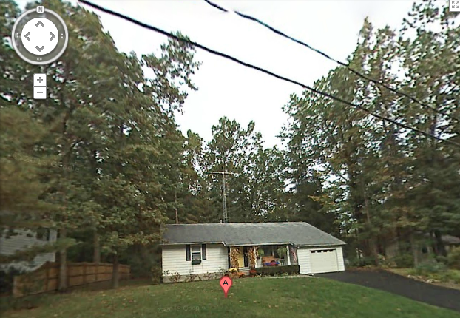
The antenna system (41’ tower, 47’ total height) which was at controversy in
Palmer v. City of Saratoga Springs, 180 F. Supp. 2d 379 (USDC NDNY 2001)(Mordue, J.), holding that an absolute height limit of 20’ was preempted as “invalid in light of PRB-1.”
Source: https://maps./google.com

