Showing of Need
for an
Amateur Radio Antenna
Support Structure

Submitted by

Peter Naumburg, CCIM
FCC licensee K5HAB
10901 Holly Avenue NE
Albuquerque NM 87122
Table of Contents

Purpose and Request 1
Amateur Radio Biography of Mr. Naumburg 2
Antenna Height and Communications Effectiveness 3
Executive Summary 4
Ionospheric Propagation 6
Horizontal Antennas Over Flat Ground 10
Beam Antennas 13
Putting The Pieces Together 14
What If the Ground Isn’t Flat? 17
Antenna Height and Interference 21
The World Is a Very Complicated Place 21
High Frequency (HF) Analysis 23
Europe 25
40 Meters 25
20 Meters 27
Oceania 29
40 Meters 29
20 Meters 31
Asia 33
40 Meters 33
20 Meters 35
Very High Frequency (VHF) Discussion 37
Performance with Current Antennas on 92 foot Structure 41
Search and Rescue Support 43
Character of the Area 46
Effect on the Neighborhood of Mr. Naumburg’s Antenna Support Structure 51
Street System: 51
Sewer System: 51
Water System: 51
Police Station: 51
Fire Station: 51
Parks: 51
Economic burden on citizens: 51
Garbage collection 52
School system 52
Emergency Communication 52
Appendix 53
Terrain Data 53
Europe 53
Oceania 54
Asia 55
SAR Mission Listing 56

Purpose and Request

- To provide a showing of need for the existing amateur radio antenna support structure at the site.

- To declare the need for, and to examine height requirements for, successful high frequency (HF) communications under the changing variables that impact Amateur Radio communications more than 50% of the time when routine communications can be expected.

- To declare the need for, and to examine height requirements for direct coverage of the greater Albuquerque area to support emergency events, as well as search and rescue operations and airplane emergency locator transmitter (ELT) locating.

Amateur Radio Biography of Mr. Naumburg

- Licensed amateur for more than 46 years
- Member American Radio Relay League (ARRL)
- Member Radio Amateur Communications Emergency Service (RACES)
- Member of Amateur Radio Emergency Services (ARES)
- Member of New Mexico Search and Rescue Team
- Holder of Extra Class (the highest degree) FCC license
IMPORTANCE OF ANTENNA HEIGHT

Antenna Height
and
Communications Effectiveness

Second Edition

A Guide for City Planners
And
Amateur Radio Operators

By R. Dean Straw, N6BV, and Gerald L. Hall, K1TD
Senior Assistant Technical Editor and Retired Associate Technical Editor

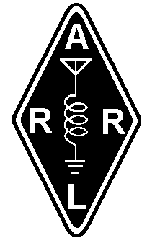

Copyright ©1999
The American Radio Relay League, Inc.
225 Main Street
Newington, CT 06111

Executive Summary
Amateur radio operators, or “hams” as they are called, communicate with stations located all over the world. Some contacts may be local in nature, while others may be literally halfway around the world. Hams use a variety of internationally allocated frequencies to accomplish their communications.
Except for local contacts, which are usually made on Very High and Ultra High Frequencies (VHF and UHF), communicating between any two points on the earth rely primarily on high-frequency (HF) signals propagating through the ionosphere. The earth’s ionosphere acts much like a mirror at heights of about 150 miles. The vertical angle of radiation of a signal launched from an antenna is one of the key factors in determining effective communication. The ability to communicate over long distances generally requires a low radiation angle, meaning that an antenna must be placed high above the ground in terms of the wavelength of the radio wave being transmitted.
A beam type of antenna at a height of 70 feet or more will provide superior performance over the same antenna at 35 feet, all other factors being equal. A height of 120 feet or even higher will provide even more advantages for long-distance communications. To a distant receiving station, a transmitting antenna at 120 feet will provide the effect of approximately 8 to 10 times more transmitting power than the same antenna at 35 feet. Depending on the level of noise and interference, this performance disparity is often enough to mean the difference between making distant radio contact with fairly reliable signals, and being unable to make distant contact at all.
Radio Amateurs have a well-deserved reputation for providing vital communications in emergency situations such as in the aftermath of a severe ice storm, a hurricane or an earthquake. Short-range communications at VHF or UHF frequencies also require sufficient antenna heights above the local terrain to ensure that the antenna has a clear view of the horizon.
In terms of safety and aesthetic considerations, it might seem intuitively reasonable for a planning board to want to restrict antenna installations to low heights. However, such height restrictions often prove very counterproductive and frustrating to all parties involved. If an amateur is restricted to low antenna heights, say 35 feet, he will suffer from poor transmission of his own signals as well as poor reception of distant signals. In an attempt to compensate on the transmitting side (he can’t do anything about the poor reception problem), he might boost his transmitted power, from 100 watts up to 1,500 watts, the maximum legal limit. This ten-fold increase in power will significantly increase the potential for interference to telephones, televisions, VCRs and audio equipment in his neighborhood.
Instead, if the antenna can be moved farther away from neighboring electronic devices—putting it higher, in other words—this will greatly reduce the likelihood of interference, which decreases at the inverse square of the distance. For example, doubling the distance reduces the potential for interference by 75%. As a further benefit, a large antenna doesn’t look as large at 120 feet as it does at 35 feet.
As a not-so-inconsequential side benefit, moving an antenna higher will also greatly reduce the potential of exposure to electromagnetic fields for neighboring human and animals. Interference and radio frequency (RF) exposure standards are covered and controlled by Federal Regulations.

Antenna Height and Communications
Effectiveness

By R. Dean Straw, N6BV, and Gerald L. Hall, K1TD
Senior Assistant Technical Editor and Retired Associate Technical Editor

The purpose of this paper is to provide general information about communications effectiveness as related to the physical height of antennas. The intended audience is amateur radio operators and the city and town Planning Boards before which a radio amateur must sometimes appear to obtain building permits for radio towers and antennas.
The performance of horizontally polarized antennas at heights of 35, 70 and 120 feet is examined in detail. Vertically polarized arrays are not considered here because at short-wave frequencies, over average terrain and at low radiation angles, they are usually less effective than horizontal antennas.

Ionospheric Propagation
Frequencies between 3 and 30 megahertz (abbreviated MHz) are often called the “short-wave” bands. In engineering terms this range of frequencies is defined as the high-frequency or HF portion of the radio spectrum. HF radio communications between two points that are separated by more than about 15 to 25 miles depend almost solely on propagation of radio signals through the ionosphere. The ionosphere is a region of the Earth’s upper atmosphere that is ionized primarily by ultraviolet rays from the Sun.
The Earth’s ionosphere has the property that it will refract or bend radio waves passing through it. The ionosphere is not a single “blanket” of ionization. Instead, for a number of complex reasons, a few discrete layers are formed at different heights above the earth. From the standpoint of radio propagation, each ionized layer has distinctive characteristics, related primarily to different amounts of ionization in the various layers. The ionized layer that is most useful for HF radio communication is called the F layer.
The F layer exists at heights varying from approximately 130 to 260 miles above the earth’s surface. Both the layer height and the amount of ionization depend on the latitude from the equator, the time of day, the season of the year, and on the level of sunspot activity. Sunspot activity varies generally in cycles that are approximately 11 years in duration, although short-term bursts of activity may create changes in propagation conditions that last anywhere from a few minutes to several days. The ionosphere is not homogeneous, and is undergoing continual change. In fact, the exact state of the ionosphere at any one time is so variable that is best described in statistical terms.
The F layer disappears at night in periods of low and medium solar activity, as the ultraviolet energy required to sustain ionization is no longer received from the Sun. The amount that a passing radio wave will bend in an ionospheric layer is directly related to the intensity of ionization in that layer, and to the frequency of the radio wave.
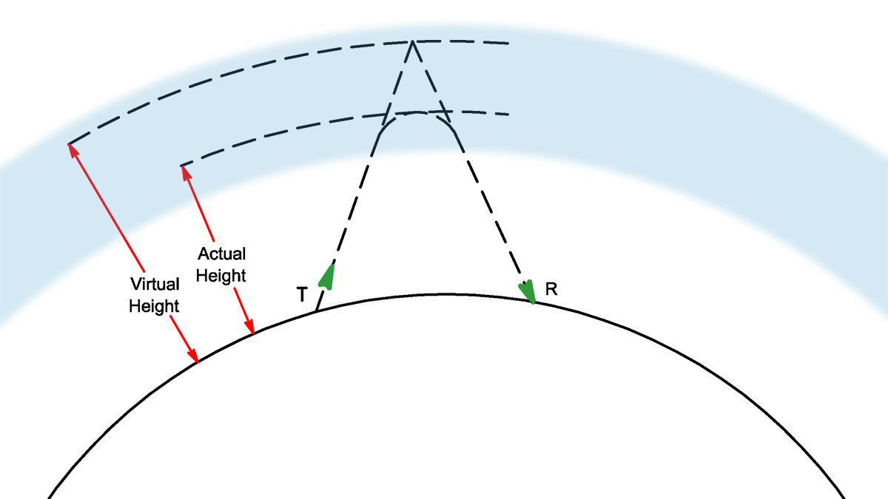

Fig 1—A simplified cross-sectional representation of ionospheric propagation. The simple triangle goes from the Transmitter T up to the virtual height and then back down to the Receiver R. Typically the F layer exists at a height of 150 miles above the Earth at mid-latitudes. The distance between T and R may range from a few miles to 2500 miles under normal propagation conditions.
A triangle may be used to portray the cross-sectional path of ionospheric radio-wave travel, as shown in Fig 1, a highly simplified picture of what happens in propagation of radio waves. The base of the triangle is the surface of the Earth between two distant points, and the apex of the triangle is the point representing refraction in the ionosphere. If all the necessary conditions are met, the radio wave will travel from the first point on the Earth’s surface to the ionosphere, where it will be bent (refracted) sufficiently to travel to the second point on the earth, many hundreds of miles away.
Of course the Earth’s surface is not a flat plane, but instead is curved. High-frequency radio waves behave in essentially the same manner as light waves—they tend to travel in straight lines, but with a slight amount of downward bending caused by refraction in the air. For this reason it is not possible to communicate by a direct path over distances greater than about 15 to 25 miles in this frequency range, slightly farther than the optical horizon. The curvature of the earth causes the surface to “fall away” from the path of the radio wave with greater distances. Therefore, it is the ionosphere that permits HF radio communications to be made between points separated by hundreds or even thousands of miles. The range of frequencies from 3 to 30 MHz is unique in this respect, as ionospheric propagation is not consistently supported for any frequencies outside this range.
One of the necessary conditions for ionospheric communications is that the radio wave must encounter the ionosphere at the correct angle. This is illustrated in Fig 2, another very simplified drawing of the geometry involved. Radio waves leaving the earth at high elevation angles above the horizon may receive only very slight bending due to refraction, and are then lost to outer space. For the same fixed frequency of operation, as the elevation angle is lowered toward the horizon, a point is reached where the bending of the wave is sufficient to return the wave to the Earth. At successively lower angles, the wave returns to the Earth at increasing distances.
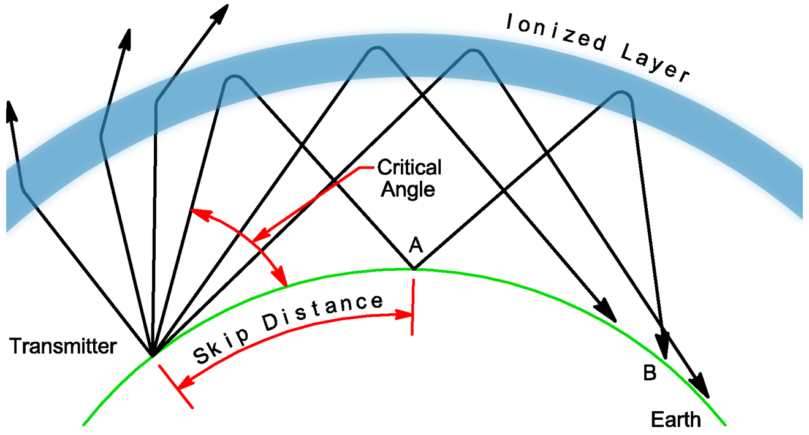

Fig 2—Behavior of radio waves encountering the ionosphere. Rays entering the ionized region at angles above the critical angle are not bent enough to return to Earth and are lost to space. Waves entering at angles below the critical angle reach the Earth at increasingly greater distances as the angle approaches the horizontal. The maximum distance that may normally be covered in a single hop is 2500 miles. Greater distances may be covered with multiple hops.
If the radio wave leaves the earth at an elevation angle of zero degrees, just toward the horizon (or just tangent to the earth’s surface), the maximum distance that may be reached under usual ionospheric conditions is approximately 2,500 miles (4,000 kilometers). However, the Earth itself also acts as a reflector of radio waves coming down from the ionosphere. Quite often a radio signal will be reflected from the reception point on the Earth back into the ionosphere again, reaching the Earth a second time at a still more distant point.
As in the case of light waves, the angle of reflection is the same as the angle of incidence, so a wave striking the surface of the Earth at an angle of, say, 15º is reflected upward from the surface at the same angle. Thus, the distance to the second point of reception will be approximately twice the distance of the first. This effect is also illustrated in Fig 2, where the signal travels from the transmitter at the left of the drawing via the ionosphere to Point A, in the center of the drawing. From Point A the signal travels via the ionosphere again to Point B, at the right. A signal traveling from the Earth through the ionosphere and back to the Earth is called a hop. Under some conditions it is possible for as many as four or five signal hops to occur over a radio path, but no more than two or three hops is the norm. In this way, HF communications can be conducted over thousands of miles.
With regard to signal hopping, two important points should be recognized. First, a significant loss of signal occurs with each hop. Lower layers of the ionosphere absorb energy from the signals as they pass through, and the ionosphere tends to scatter the radio energy in various directions, rather than confining it to a tight bundle. The earth also scatters the energy at a reflection point. Thus, only a small fraction of the transmitted energy actually reaches a distant receiving point.
Again refer to Fig 2. Two radio paths are shown from the transmitter to Point B, a one-hop path and a two-hop path. Measurements indicate that although there can be great variation in the ratio of the two signal strengths in a situation such as this, the signal power received at Point B will generally be from five to ten times greater for the one-hop wave than for the two-hop wave. (The terrain at the mid-path reflection point for the two-hop wave, the angle at which the wave is reflected from the earth, and the condition of the ionosphere in the vicinity of all the refraction points are the primary factors in determining the signal-strength ratio.) Signal levels are generally compared in decibels, abbreviated dB. The decibel is a logarithmic unit. Three decibels difference in signal strengths is equivalent to a power ratio of 2:1; a difference of 10 dB equates to a power ratio of 10:1. Thus the signal loss for an additional hop is about 7 to 10 dB.
The additional loss per hop becomes significant at greater distances. For a simplified example, a distance of 4,000 miles can be covered in two hops of 2,000 miles each or in four hops of 1,000 miles each. For illustration, assume the loss for additional hops is 10 dB, or a 1/10 power ratio. Under such conditions, the four-hop signal will be received with only 1/100 the power or 20 dB below that received in two hops. The reason for this is that only 1/10 of the two-hop signal is received for the first additional (3rd) hop, and only 1/10 of that 1/10 for the second additional (4th) hop. It is for this reason that no more than four or five propagation hops are useful; the received signal eventually becomes too weak to be heard.
The second important point to be recognized in multihop propagation is that the geometry of the first hop establishes the geometry for all succeeding hops. And it is the elevation angle at the transmitter that sets up the geometry for the first hop.
It should be obvious from the preceding discussion that one needs a detailed knowledge of the range of elevation angles for effective communication in order to do a scientific evaluation of a possible communications circuit. The range of angles should be statistically valid over the full 11-year solar sunspot cycle, since the behavior of the Sun determines the changes in the nature of the Earth’s ionosphere. ARRL did a very detailed computer study in the early 1990s to determine the angles needed for propagation throughout the world. The results of this study will be examined later, after we introduce the relationship between antenna height and the elevation pattern for an antenna.

Horizontal Antennas Over Flat Ground
A simple antenna that is commonly used for HF communications is the horizontal half-wave dipole. The dipole is a straight length of wire (or tubing) into which radio-frequency energy is fed at the center. Because of its simplicity, the dipole may be easily subjected to theoretical performance analyses. Further, the results of proper analyses are well borne out in practice. For these reasons, the half-wave dipole is a convenient performance standard against which other antenna systems can be compared.
Because the earth acts as a reflector for HF radio waves, the directive properties of any antenna are modified considerably by the ground underneath it. If a dipole antenna is placed horizontally above the ground, most of the energy radiated downward from the dipole is reflected upward. The reflected waves combine with the direct waves (those radiated at angles above the horizontal) in various ways, depending on the height of the antenna, the frequency, and the electrical characteristics of the ground under and around the antenna.
At some vertical angles above the horizon, the direct and reflected waves may be exactly in phase—that is, the maximum signal or field strengths of both waves are reached at the same instant at some distant point. In this case the resultant field strength is equal to the sum of the two components. At other vertical angles the two waves may be completely out of phase at some distant point—that is, the fields are maximum at the same instant but the phase directions are opposite. The resultant field strength in this case is the difference between the two. At still other angles the resultant field will have intermediate values. Thus, the effect of the ground is to increase the intensity of radiation at some vertical angles and to decrease it at others. The elevation angles at which the maxima and minima occur depend primarily on the antenna height above ground. (The electrical characteristics of the ground have some slight effect too.)
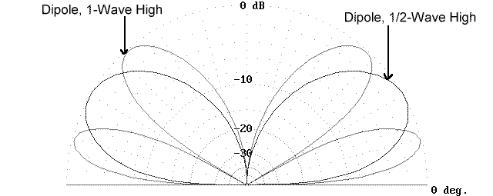
Fig 3–Comparison of elevation responses for two dipoles: one ½-wavelength high, and the other 1-wavelength high.
For simplicity here, we consider the ground to be a perfectly conducting, perfectly flat reflector, so that straightforward trigonometric calculations can be made to determine the relative amount of radiation intensity at any vertical angle for any dipole height. Graphs from such calculations are often plotted on rectangular axes to show best resolution over particularly useful ranges of elevation angles, although they are also shown on polar plots so that both the front and back of the response can be examined easily. Fig 3 shows an overlay of the polar elevation-pattern responses of two dipoles at different heights over perfectly conducting flat ground. The lower dipole is located a half wavelength above ground, while the higher dipole is located one wavelength above ground. The pattern of the lower antenna peaks at an elevation angle of about 30º, while the higher antenna has two main lobes, one peaking at 15º and the other at about 50º elevation angle.
In the plots shown in Fig 3, the elevation angle above the horizon is represented in the same fashion that angles are measured on a protractor. The concentric circles are calibrated to represent ratios of field strengths, referenced to the strength represented by the outer circle. The circles are calibrated in decibels. Diminishing strengths are plotted toward the center.
You may have noted that antenna heights are often discussed in terms of wavelengths. The reason for this is that the length of a radio wave is inversely proportional to its frequency. Therefore a fixed physical height will represent different electrical heights at different radio frequencies. For example, a height of 70 feet represents one wavelength at a frequency of 14 MHz. But the same 70-foot height represents a half wavelength for a frequency of 7 MHz and only a quarter wavelength at 3.5 MHz. On the other hand, 70 feet is 2 wavelengths high at 28 MHz.
The lobes and nulls of the patterns shown in Fig 3 illustrate what was described earlier, that the effect of the ground beneath an antenna is to increase the intensity of radiation at some vertical elevation angles and to decrease it at others. At a height of a half wavelength, the radiated energy is strongest at a rather high elevation angle of 30º. This would represent the situation for a 14-MHz dipole 35 feet off the ground.
As the horizontal antenna is raised to greater heights, additional lobes are formed, and the lower ones move closer to the horizon. The maximum amplitude of each of the lobes is roughly equal. As may be seen in Fig 3, for an antenna height of one wavelength, the energy in the lowest lobe is strongest at 15º. This would represent the situation for a 14-MHz dipole 70 feet high.
$θ={\text{sin}}^{−1}\left(\frac{0\text{.}\text{25}}{h}\right)$The elevation angle of the lowest lobe for a horizontal antenna above perfectly conducting ground may be determined mathematically:
Where
θ = the wave or elevation angle
h = the antenna height above ground in wavelengths
In short, the higher the horizontal antenna, the lower is the lowest lobe of the pattern. As a very general rule of thumb, the higher an HF antenna can be placed above ground, the farther it will provide effective communications because of the resulting lower radiation angle. This is true for any horizontal antenna over real as well as theoretically perfect ground.
You should note that the nulls in the elevation pattern can play an important role in communications—or lack of communication. If a signal arrives at an angle where the antenna system exhibits a deep null, communication effectiveness will be greatly reduced. It is thus quite possible that an antenna can be too high for good communications efficiency on a particular frequency. Although this rarely arises as a significant problem on the amateur bands below 14 MHz, we’ll discuss the subject of optimal height in more detail later.
Actual earth does not reflect all the radio-frequency energy striking it; some absorption takes place. Over real earth, therefore, the patterns will be slightly different than those shown in Fig 3, however the differences between theoretical and perfect earth ground are not significant for the range of elevation angles necessary for good HF communication. Modern computer programs can do accurate evaluations, taking all the significant ground-related factors into account.

Beam Antennas
For point-to-point communications, it is beneficial to concentrate the radiated energy into a beam that can be aimed toward a distant point. An analogy can be made by comparing the light from a bare electric bulb to that from an automobile headlight, which incorporates a built-in focusing lens. For illuminating a distant point, the headlight is far more effective.
Antennas designed to concentrate the radiated energy into a beam are called, naturally enough, beam antennas. For a fixed amount of transmitter power fed to the transmitting antenna, beam antennas provide increased signal strength at a distant receiver. In radio communications, the use of a beam antenna is also beneficial during reception, because the antenna pattern for transmission is the same for reception. A beam antenna helps to reject signals from unwanted directions, and in effect boosts the strength of signals received from the desired direction.
The increase in signal or field strength a beam antenna offers is frequently referenced to a dipole antenna in free space (or to another theoretical antenna in free space called an isotropic antenna) by a term called gain. Gain is commonly expressed in decibels. The isotropic antenna is defined as being one that radiates equally well in all directions, much like the way a bare light bulb radiates essentially equally in all directions.
One particularly well-known type of beam antenna is called a Yagi, named after one of its Japanese inventors. Different varieties of Yagi antennas exist, each having somewhat different characteristics. Many television antenna are forms of multi-element Yagi beam antennas. In the next section of this paper, we will refer to a four-element Yagi, with a gain of 8.5 dBi in free space, exclusive of any influence due to ground.
This antenna has 8.5 dB more gain than an isotropic antenna in free space and it achieves that gain by squeezing the pattern in certain desired directions. Think of a normally round balloon and imagine squeezing that balloon to elongate it in one direction. The increased length in one direction comes at the expense of length in other directions. This is analogous to how an antenna achieves more signal strength in one direction, at the expense of signal strength in other directions.
The elevation pattern for a Yagi over flat ground will vary with the electrical height over ground in exactly the same manner as for a simpler dipole antenna. The Yagi is one of the most common antennas employed by radio amateurs, second in popularity only to the dipole.

Putting The Pieces Together
In Fig 4, the elevation angles necessary for communication from a particular transmitting site, in Boston, Massachusetts, to the continent of Europe using the 14-MHz amateur band are shown in the form of a bargraph. For each elevation angle from 1º to 30º, Fig 4 shows the percentage of time when the 14-MHz band is open at each elevation angle. For example, 5º is the elevation angle that occurs 12% of the time when the band is available for communication, while 11º occurs just under 10% of the time when the band is open. The useful range of elevation angles that must accommodated by an amateur station wishing to talk to Europe from Boston is from 1º to 28º.
In addition to the bar-graph elevation-angle statistics shown in Fig 4, the elevation pattern responses for three Yagi antennas, located at three different heights above flat ground, are overlaid on the same graph. You can easily see that the 120-foot antenna is the best antenna to cover all the possible angles for this particular frequency, although it suffers at the higher elevation angles on this particular propagation path, beyond about 12°. If, however, you can accept somewhat lower gain at the lowest angles, the 70-foot antenna would arguably be the best overall choice to cover all the elevation angles.
Other graphs are needed to show other target receiving areas around the world. For comparison, Fig 5 is also for the 14-MHz band, but this time from Boston to Sydney, Australia. The peak angle for this very long path is about 2º, occurring 19% of the time when the band is actually open for communication. Here, even the 120-foot high antenna is not ideal. Nonetheless, at the 5° elevation angle, the 120-foot antenna is still about 10 dB better than the one at 35 feet.
Fig 4 and Fig 5 have portrayed the situation for the 14-MHz amateur band, the most popular and heavily utilized HF band used by radio amateurs. During medium to high levels of solar sunspot activity, the 21 and 28-MHz amateur bands are open during the daytime for long-distance communication. Fig 6 illustrates the 28-MHz elevation-angle statistics, compared to the elevation patterns for the same three antenna heights shown in Fig 5. Clearly, the elevation response for the 120-foot antenna has a severe (and undesirable) null at 8°. The 120-foot antenna is almost 3.4 wavelengths high on 28 MHz (whereas it is 1.7 wavelengths high on 14 MHz.) For certain launch angles, the 120-foot high Yagi on 28 MHz would simply be too high.
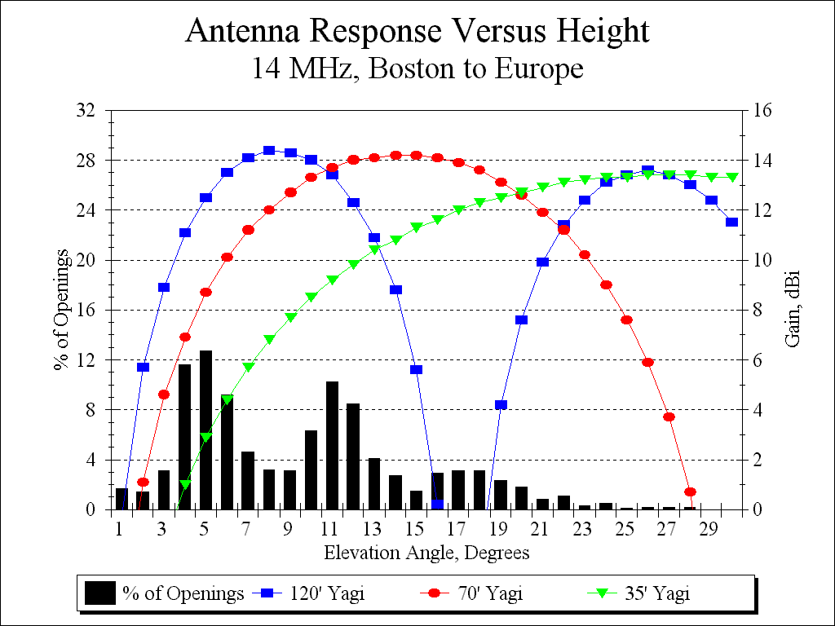

Fig 4—Elevation response patterns of three Yagis at 120, 70 and 35 feet, at 14 MHz over flat ground. The patterns are overlaid with the statistical elevation-angles for the path from Boston to continental Europe over the entire 11-year solar sunspot cycle. Clearly, the 120-foot antenna is the best choice to cover the angles needed, but it suffers some at higher angles.
The radio amateur who must operate on a variety of frequencies might require two or more towers at different heights to maintain proper elevation coverage on all the authorized bands. Antennas can sometimes be mounted at different heights on a single supporting tower, although it is more difficult to rotate antennas that are “vertically stacked” around the tower to point in all the needed directions. Further, closely spaced antennas tuned to different frequencies usually interact electrically with each other, often causing severe performance degradation.
During periods of low to moderate sunspot activity (about 50% of the 11-year solar cycle), the 14-MHz band closes down for propagation in the early evening. A radio amateur wishing to continue communication must shift to a lower frequency band. The next most highly used band below the 14-MHz band is the 7-MHz amateur band. Fig 7 portrays a 7-MHz case for another transmitting site, this time from San Francisco, California, to the European continent. Now, the range of necessary elevation angles is from about 1° to 16°, with a peak statistical likelihood of about 16% occurring at an elevation of 3°. At this low elevation angle, a 7-MHz antenna must be very high in the air to be effective. Even the 120-foot antenna is hardly optimal for the peak angle of 3°. The 200-foot antenna shown would be far better than a 120-foot antenna. Further, the 35-foot high antenna is far inferior to the other antennas on this path and would provide far less capabilities, on both receiving and transmitting.
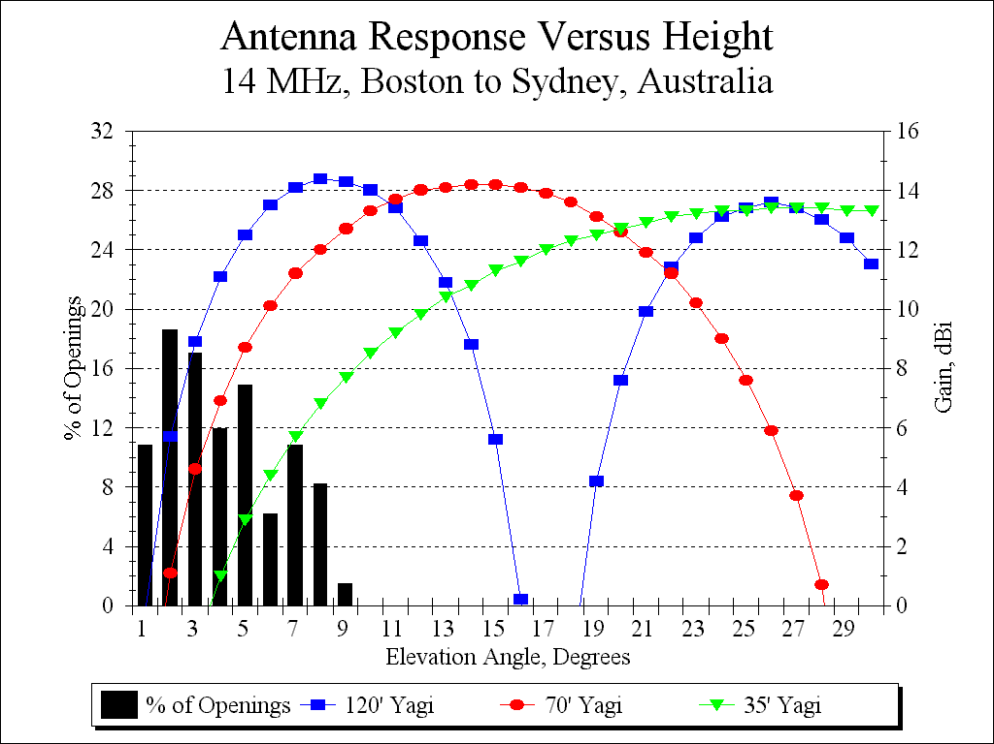

Fig 5—Elevation responses for same antennas as Fig 4, but for a longer-range path from Boston to Sydney, Australia. Note that the prevailing elevation angles are very low.
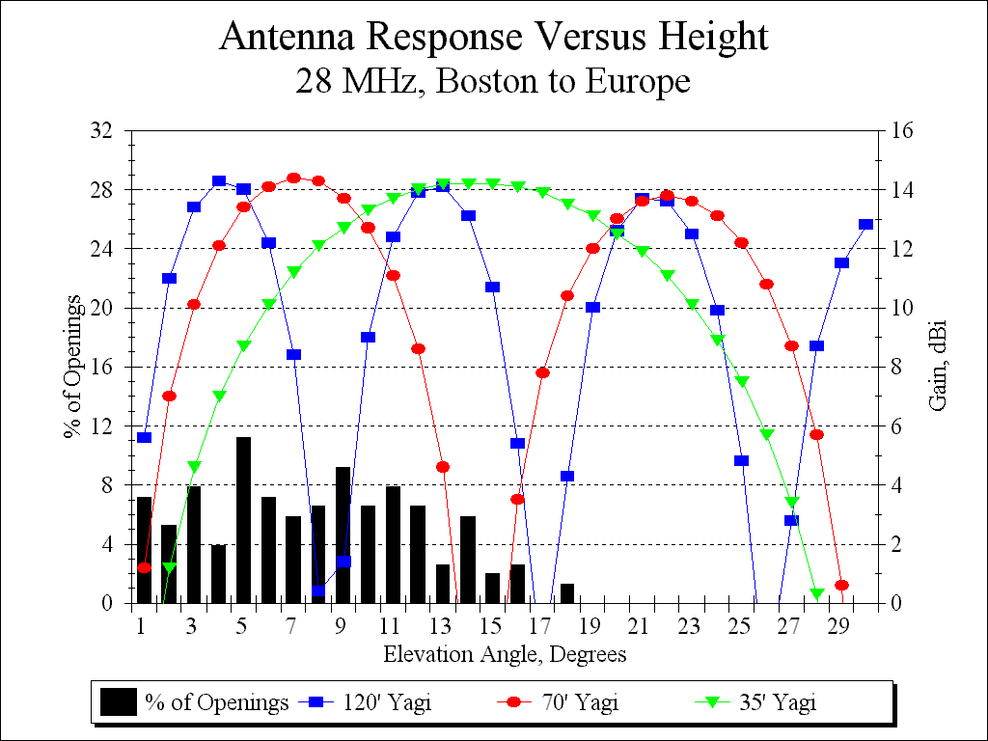

Fig 6—Elevation angles compared to antenna responses for 28-MHz path from Boston to Europe. The 70-foot antenna is the best choice on this path.
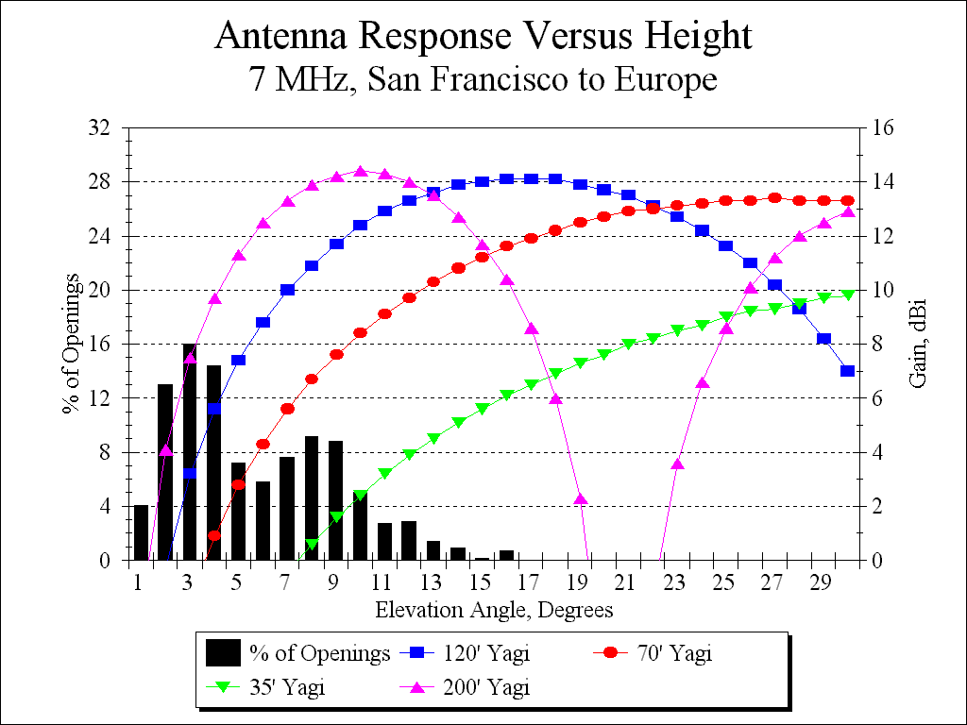

Fig 7—Comparison of antenna responses for another propagation path: from San Francisco to Europe on 7 MHz. Here, even a 120-foot high antenna is hardly optimal for the very low elevation angles required on this very long path. In fact, a 200-foot high antenna is far better suited for this path.

What If the Ground Isn’t Flat?
In the preceding discussion, antenna radiation patterns were computed for antennas located over flat ground. Things get much more complicated when the exact local terrain surrounding a tower and antenna are taken into account. In the last few years, sophisticated ray-tracing computer models have become available that can calculate the effect that local terrain has on the elevation patterns for real-world HF installations—and each real-world situation is indeed different.
For simplicity, first consider an antenna on the top of a hill with a constant slope downward. The general effect is to lower the effective elevation angle by an amount equal to the downslope of the hill. For example, if the downslope is −3° for a long distance away from the tower and the flat-ground peak elevation angle is 10° (due to the height of the antenna), then the net result will be 10° − 3° = 7° peak angle. However, if the local terrain is rough, with many bumps and valleys in the desired direction, the response can be modified considerably. Fig 8 shows the fairly complicated terrain profile for Jan Carman, K5MA, in the direction of Japan. Jan is located on one of the tallest hills in West Falmouth, Massachusetts. Within 500 feet of his tower is a small hill with a water tower on the top, and then the ground gradually falls away, so that at a distance of about 3000 feet from the tower base, the elevation has fallen to sea level, at 0 feet.
The computed responses toward Japan from this location, using a 120-foot and a 70-foot high Yagi, are shown in Fig 9, overlaid for comparison with the response for a 120-foot Yagi over flat ground. Over this particular terrain, the elevation pattern for the 70-foot antenna is actually better than that of the 120-foot antenna for angles below about 3°, but not for medium angles! The responses for each height oscillate around the pattern for flat ground—all due to the complex reflections and diffractions occurring off the terrain.
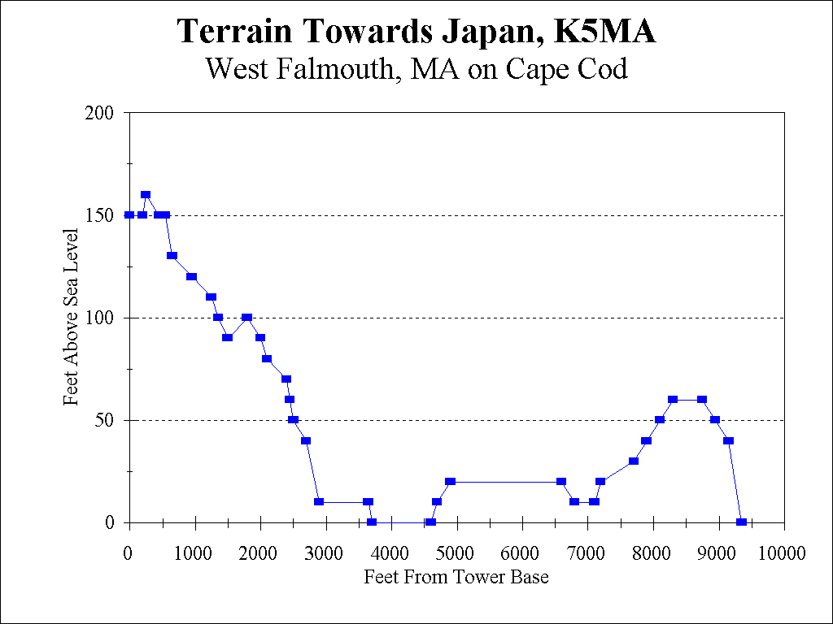

Fig 8—Terrain profile from location of K5MA, Jan Carman, in West Falmouth, MA, towards Japan. This is a moderately complicated real-world terrain on one of the highest hills on Cape Cod.
At an elevation angle of 5°, the situation reverses itself and the gain is now higher for the 120-foot-high antenna than for the 70-foot antenna. A pair of antennas on one tower would be required to cover all the angles properly. To avoid any electrical interactions between similar antennas on one tower, two towers would be much better. Compared to the flat-ground situation, the responses of real-world antennas can be very complicated due to the interactions with the local terrain.
Fig 10 shows the situation for the same Cape Cod location, but now for 7 MHz. Again, it is clear that the 120-foot high Yagi is superior by at least 3 dB (equivalent to twice the power) to the 70-foot high antenna at the statistical elevation angle of 6°. However, the response of the real-world 120-foot high antenna is still up some 2 dB from the response for an identical antenna over flat ground at this angle. On this frequency, the local terrain has helped boost the gain at the medium angles more than a similar antenna 120 feet over flat ground. The gain is even greater at lower angles, say at 1° elevation, where most signals take off, statistically speaking. Putting the antenna up higher, say 150 feet, will help the situation at this location, as would adding an additional Yagi at the 70-foot level and feeding both antennas in phase as a vertical stack.

Although the preceding discussion has been in terms of the transmitting antenna, the same principles apply when the antenna is used for reception. A high antenna will receive low-angle signals more effectively than will a low antenna. Indeed, amateur operators know very well that “If you can’t hear them, you can’t talk to them.” Stations with tall towers can usually hear far better than their counterparts with low installations.

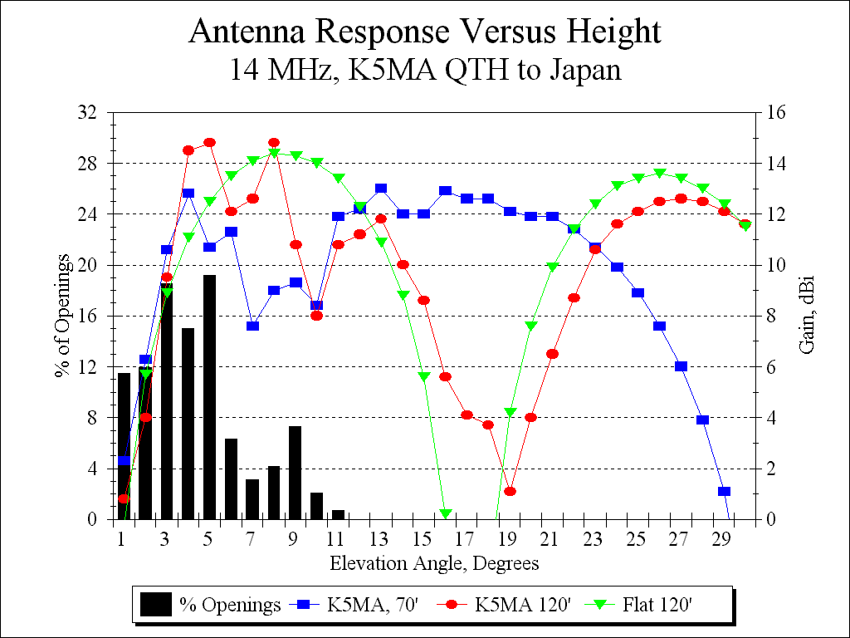

Fig 9—Computed elevation responses of 120- and 70-foot high Yagis, at the K5MA location on Cape Cod, in the direction of Japan and over flat ground, for comparison. The elevation response of the real-world antenna has been significantly modified by the local terrain.
The situation becomes even more difficult for the next lowest amateur band at 3.5 MHz, where optimal antenna heights for effective long-range communication become truly heroic! Towers that exceed 120 feet are commonplace among amateurs wishing to do serious 3.5-MHz long-distance work.
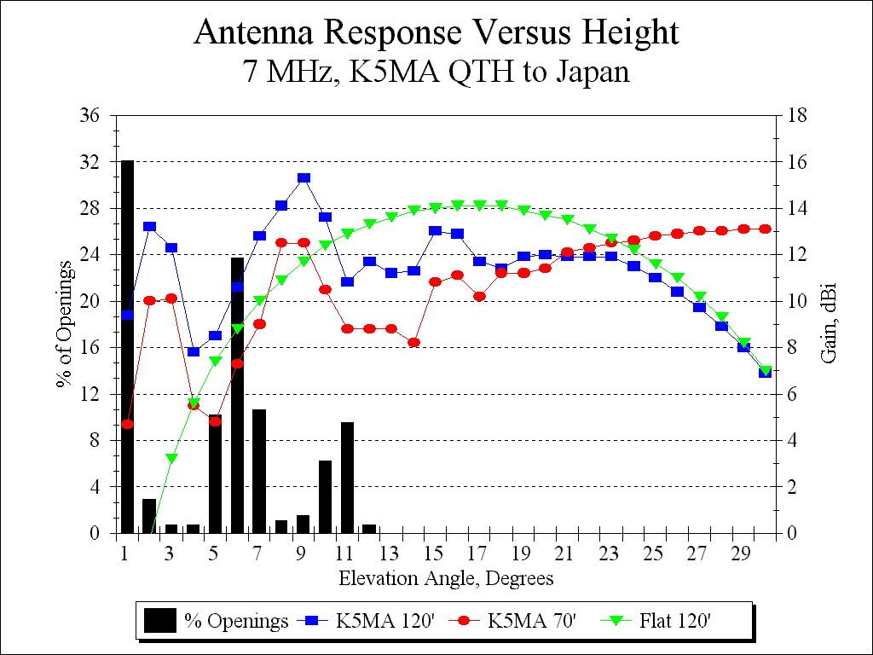

Fig 10—Elevation response on 7 MHz from K5MA location towards Japan on 7 MHz. The 120-foot high Yagi is definitely superior to the one only 70-feet high.

Local Emergencies
The 3.5 and 7-MHz amateur bands are, however, not always used strictly for long-range work. Both bands are crucial for providing communications throughout a local area, such as might be necessary in times of a local emergency. For example, earthquakes, tornadoes and hurricanes have often disrupted local communications—because telephone and power lines are down and because local police and fire-department VHF/UHF repeaters are thus knocked out of action. Radio amateurs often will use the 3.5 and 7-MHz bands to provide communications out beyond the local area affected by the disaster, perhaps into the next county or the next metropolitan area. For example, an earthquake in San Francisco might see amateurs using emergency power providing communications through amateurs in Oakland across the San Francisco Bay, or even as far away as Los Angeles or Sacramento. These places are where commercial power and telephone lines are still intact, while most power and telephones might be down in San Francisco itself. Similarly, a hurricane that selectively destroys certain towns on Cape Cod might find amateurs in these towns using 3.5 or 7.0 MHz to contact their counterparts in Boston or New York.
However, in order to get the emergency messages through, amateurs must have effective antennas. Most such relatively local emergency situations require towers of moderate height, less than about 100 feet tall typically.

Antenna Height and Interference
Extensive Federal Regulations cover the subject of interference to home electronic devices. It is an unfortunate fact of life, however, that many home electronic devices (such as stereos, TVs, telephones and VCRs) do not meet the Federal standards. They are simply inadequately designed to be resistant to rf energy in their vicinity. Thus, a perfectly legal amateur-radio transmitter may cause interference to a neighbor’s VCR or TV because cost-saving shortcuts were taken in the design and manufacture of these home entertainment devices. Unfortunately, it is difficult to explain to an irate neighbor why his brand-new $1000 stereo is receiving the perfectly legitimate transmissions by a nearby radio operator.
The potential for interference to any receiving device is a function of the transmitter power, transmitter frequency, receiver frequency, and most important of all, the proximity of the transmitter to the potential receiver. The transmitted field intensity decreases as the inverse square of the distance. This means that doubling the height of an antenna from 35 to 70 feet will reduce the potential for interference by 75%. Doubling the height again to 140 feet high would reduce the potential another 75%. Higher is better to prevent interference in the first place!
Recently enacted Federal Regulations address the potential for harm to humans because of exposure to electromagnetic fields. Amateur-radio stations rarely have problems in this area, because they use relatively low transmitting power levels and intermittent duty cycles compared to commercial operations, such as TV or FM broadcast stations. Nevertheless, the potential for rf exposure is again directly related to the distance separating the transmitting antenna and the human beings around it. Again, doubling the height will reduce potential exposure by 75%. The higher the antenna, the less there will any potential for significant rf exposure.

The World Is a Very Complicated Place
It should be pretty clear by now that designing scientifically valid communication systems is an enormously complex subject. The main complications come from the vagaries of the medium itself, the Earth’s ionosphere. However, local terrain can considerably complicate the analysis also. The main points of this paper may be summarized briefly:

The radiation elevation angle is the key factor determining effective communication distances beyond line-of-sight. Antenna height is the primary variable under control of the station builder, since antenna height affects the angle of radiation. In general, placing an amateur antenna system higher in the air enhances communication capabilities and also reduces chances for electromagnetic interference with neighbors.

High Frequency (HF) Analysis

This high frequency analysis shows signal coverage from Mr. Naumberg’s location in three directions: Europe, Oceania & Asia. Two frequency bands are used, 40 and 20 meters (7.1 MHz & 14.1 MHz, respectively). These bands were selected because antenna height is most critical at those frequencies.

The process of analysis starts by determining terrain elevation out 4,400 meters from the antenna in each of the three directions (see above). This data comes from the National Elevation Dataset (NED). The complete terrain analysis is included in the appendix of this document.

Next, the three individual terrain data sets are used in the program High Frequency Terrain Assessment (HFTA). This program provides antenna gain and take-off (elevation) angle data with consideration of the terrain elevation.

The output of the HFTA program is used as input to VOAAREA (also known as VOACAP). The development of VOAAREA HF propagation analysis program was made possible by funding from the Voice of America (VOA), the U.S. Army, and the U.S. Air Force. Area Coverage is from a transmitter to a grid of receivers for a single hour, frequency, and month/SunSpot pair. The results appear as contours of any output parameter plotted on a map background that includes world political boundaries and city locations.

The maps below are outputs from VOAAREA. In each map there are some constants. They are:

- The transmitter is located on Mr. Naumburg’s property
- The transmitter power is 1.5 kilowatts (KW), the maximum allowable
- A mean smoothed sunspot number of 100 is used (this is the mean of the current solar cycle)
- The center of the plot for Europe is Paris
- The center of the plot for Asia is Tokyo
- The center of the plot for Oceania is Sydney

In the maps, “Service Reliability” is defined as successful communications greater than 50% of otherwise available time (blackout times are not included) under the changing variables that impact amateur radio communications. It should be noted that this is a very conservative service goal, as Snook v. Missouri City (Texas), U.S. District Court, Southern District of Texas (2003), employed a service reliability standard of 75-90%.

Europe

40 Meters

Referring to Figures 11, 12 and 13 below, signals to Europe nearly meet the objective with the 92 foot structure (antenna is at 75 feet) (figure 12). A 122 foot structure (antenna at 105 feet) would completely meet the objective, however, Mr. Naumburg decided on the lower structure to be more compliant with the aesthetics of the neighborhood. The 62 foot structure (antenna at 45 feet) clearly does not meet the objective. These projections are in December at 0400 UTC. Forty meters requires a dark, night time path for long distance communications.

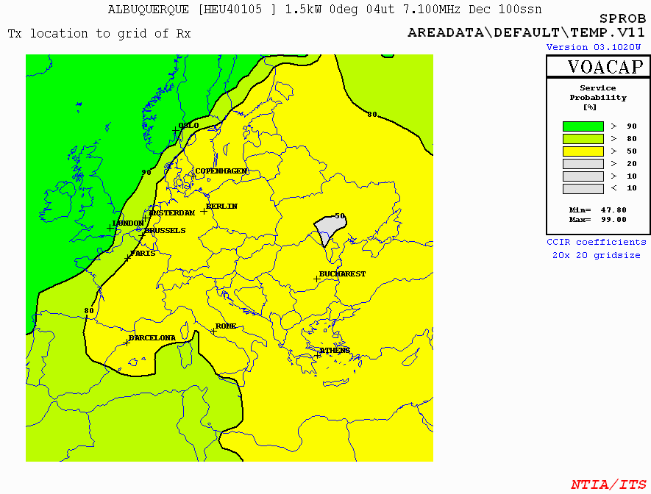

Figure 11, To Europe, 7.1 MHz (40 meters) with Antenna on 122 foot structure

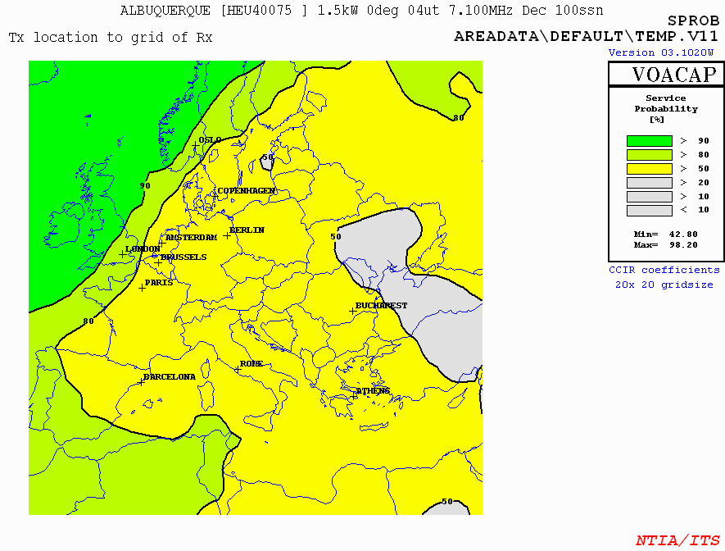

Figure 12, To Europe, 7.1 MHz (40 meters) with Antenna on 92 foot structure

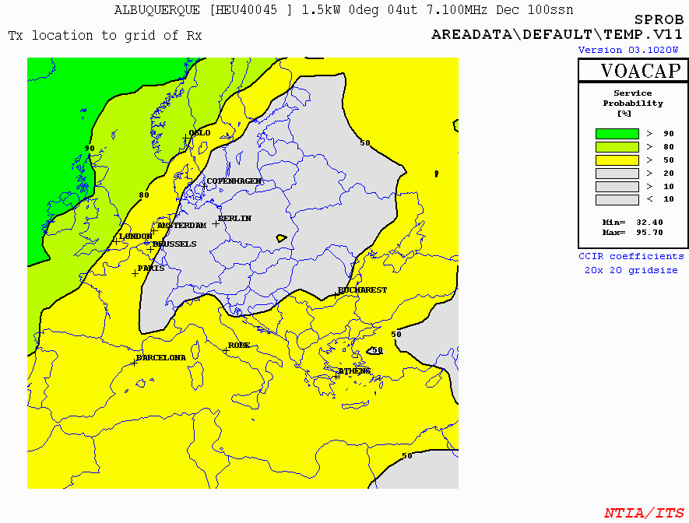

Figure 13, To Europe, 7.1 MHz (40 meters) with Antenna on 62 foot structure

20 Meters

Referring to Figures 14, 15 and 16 below, signals to Europe nearly meet the objective with the 92 foot structure (antenna is at 75 feet) (figure 15). A 122 foot structure (antenna at 105 feet) would completely meet the objective, however, Mr. Naumburg decided on the lower structure to be more compliant with the aesthetics of the neighborhood. The 62 foot structure (antenna at 45 feet) clearly does not meet the objective. These projections are in July at 0000 UTC. Twenty meters requires a light, daytime time path for long distance communications.

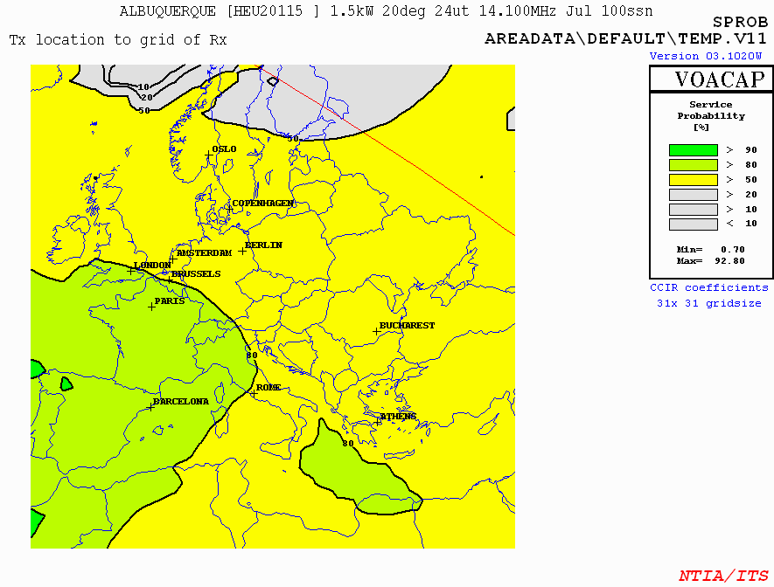

Figure 14, To Europe, 14.1 MHz (20 meters) with Antenna on 122 foot structure

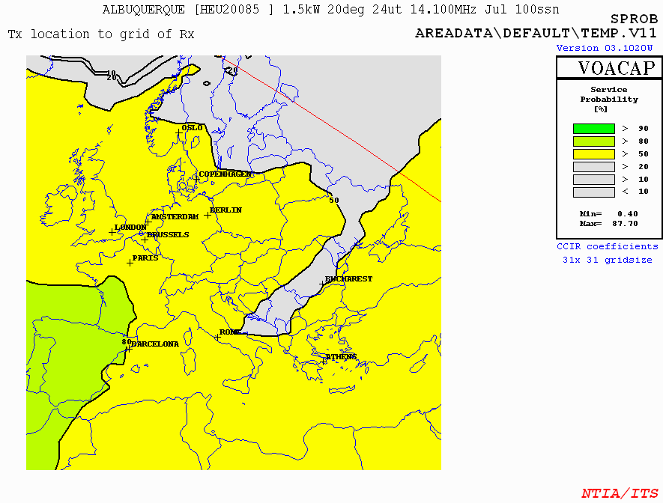

Figure 15, To Europe, 14.1 MHz (20 meters) with Antenna on 92 foot structure

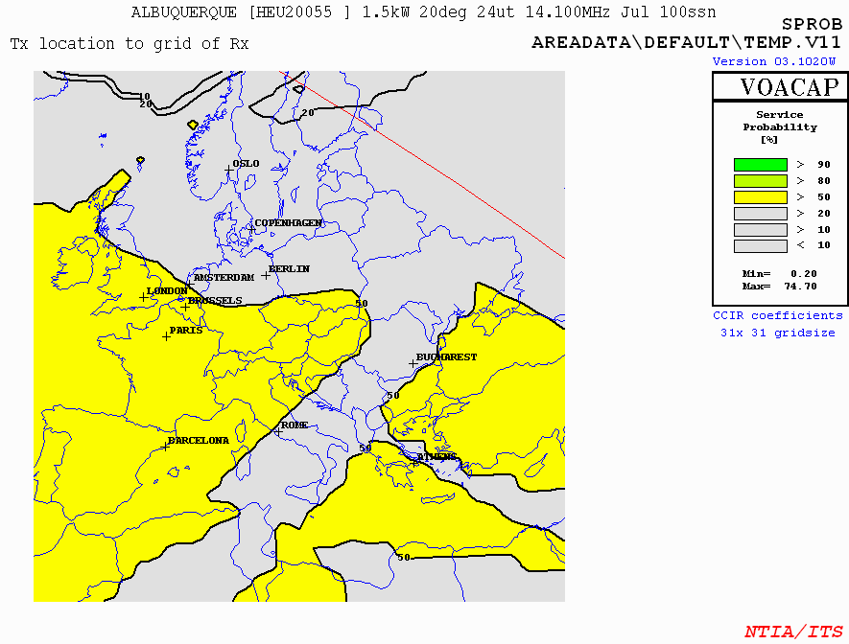

Figure 16, To Europe, 14.1 MHz (20 meters) with Antenna on 62 foot structure

Oceania

40 Meters

Referring to Figures 17, 18 and 19 below, signals to Europe nearly meet the objective with the 92 foot structure (antenna is at 75 feet) (figure 18). A 122 foot structure (antenna at 105 feet) would completely meet the objective, however, Mr. Naumburg decided on the lower structure to be more compliant with the aesthetics of the neighborhood. The 62 foot structure (antenna at 45 feet) clearly does not meet the objective. These projections are in December at 1100 UTC. Forty meters requires a dark, night time path for long distance communications.

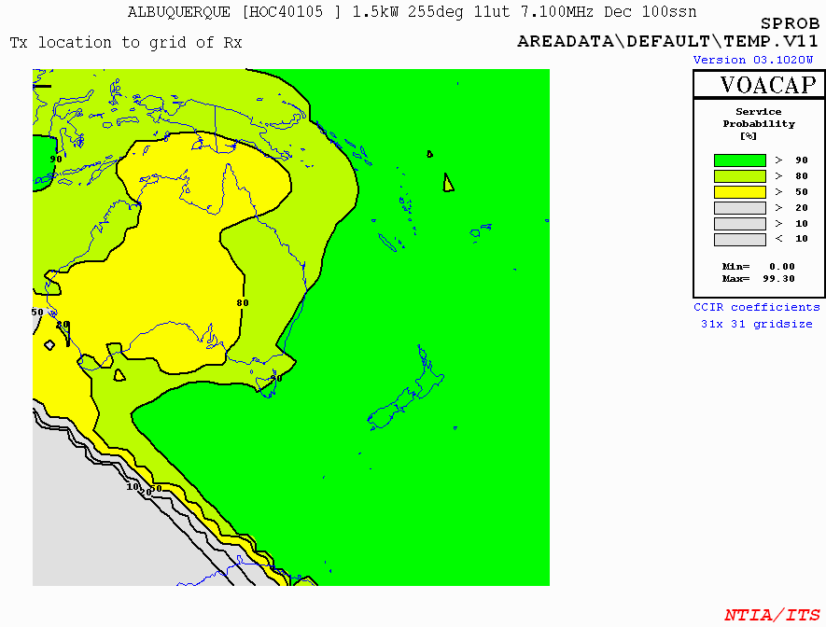
Australia

Figure 17, To Oceania, 7.1 MHz (40 meters) with Antenna on 122 foot structure

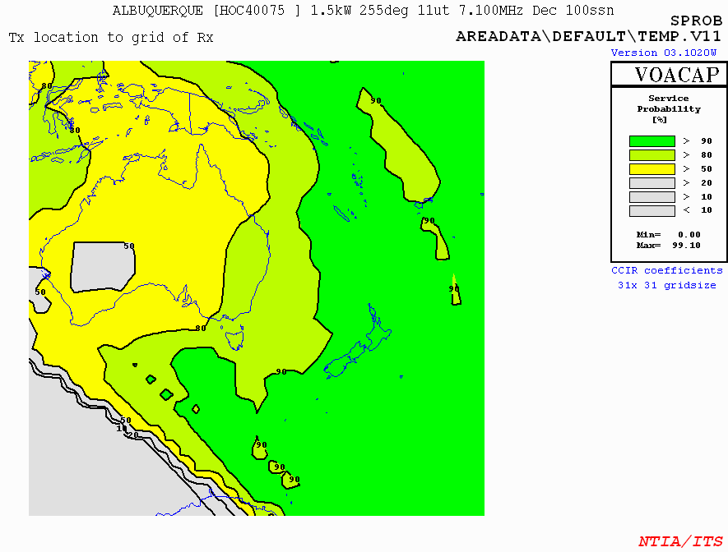
Australia

Figure 18, To Oceania, 7.1 MHz (40 meters) with Antenna on 92 foot structure

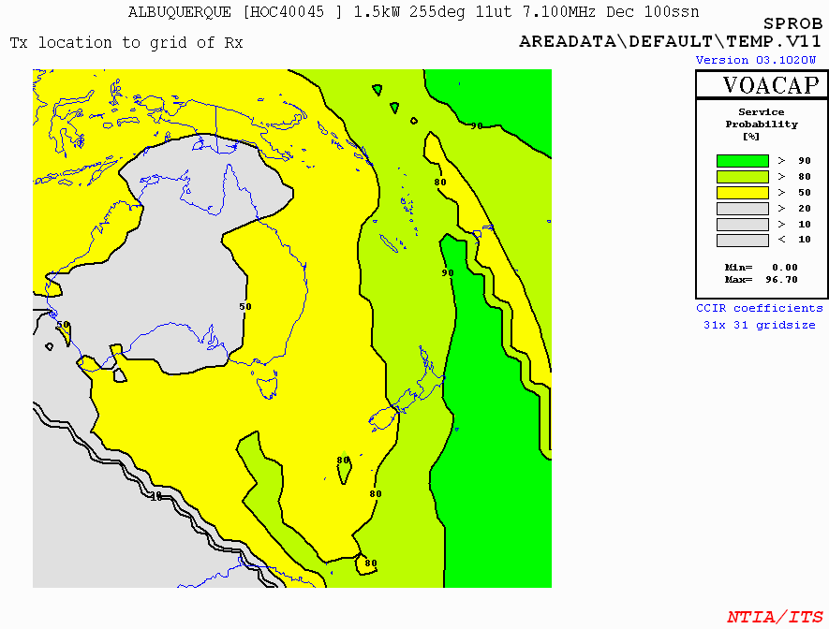
Australia

Figure 19, To Oceania, 7.1 MHz (40 meters) with Antenna on 62 foot structure

20 Meters

Referring to Figures 20, 21 and 22 below, signals to Oceania nearly meet the objective with the 92 foot structure (antenna is at 75 feet) (figure 21). A 122 foot structure (antenna at 115 feet) would completely meet the objective, however, Mr. Naumburg decided on the lower structure to be more compliant with the aesthetics of the neighborhood. The 62 foot structure (antenna at 55 feet) clearly does not meet the objective. These projections are in December at 1100 UTC. Twenty meters requires a light, daytime time path for long distance communications.

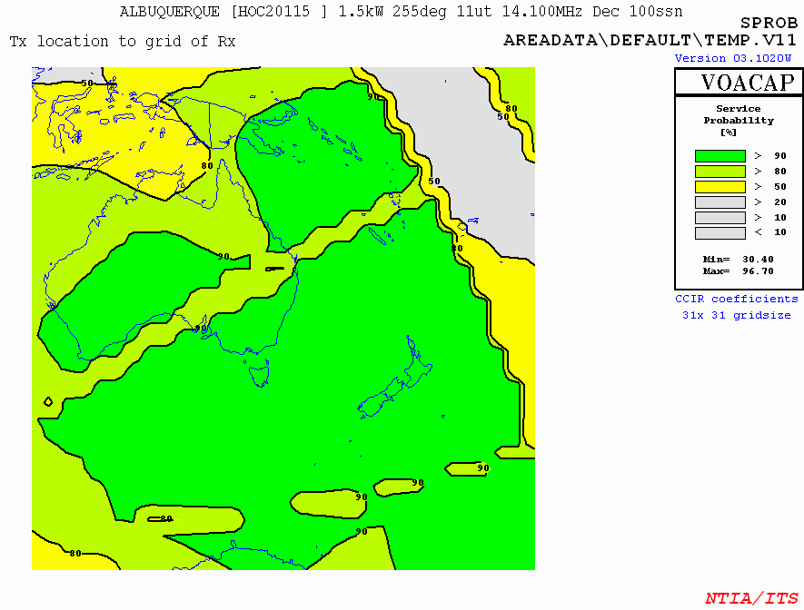
Australia

Figure 20, To Oceania, 14.1 MHz (20 meters) with Antenna on 122 foot structure
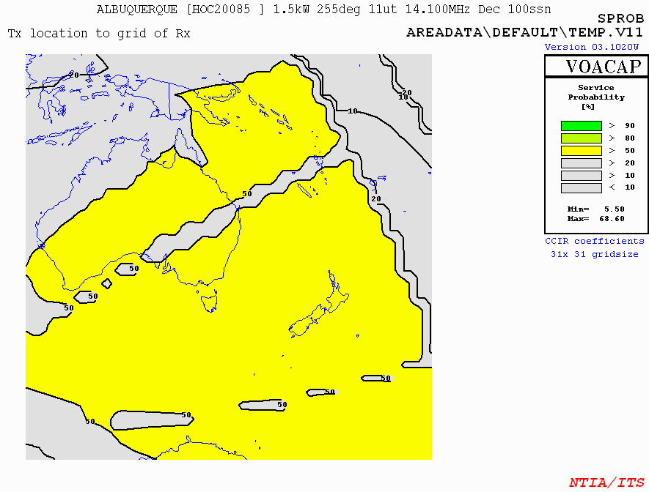
Australia

Figure 21, To Oceania, 14.1 MHz (20 meters) with Antenna on 92 foot structure

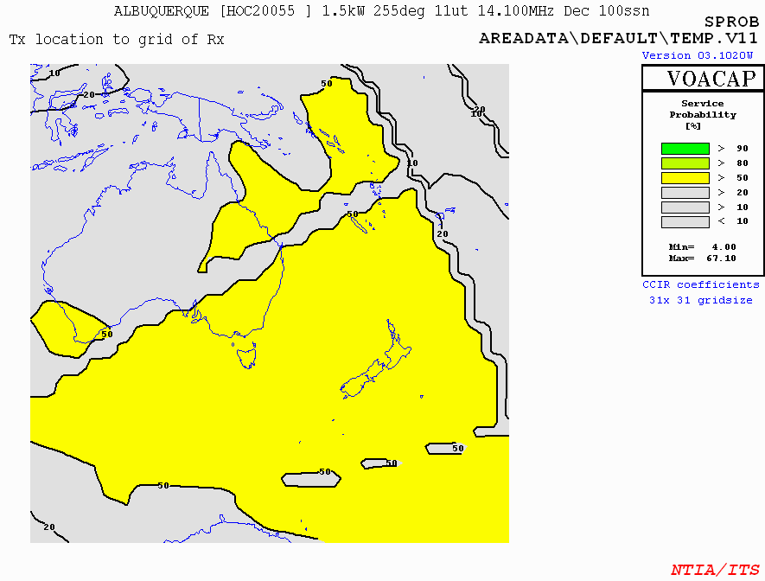
Australia

Figure 22, To Oceania, 14.1 MHz (20 meters) with Antenna on 62 foot structure

Asia

40 Meters

Referring to Figures 23, 24 and 25, below, signals to Asia nearly meet the objective with the 92 foot structure (antenna is at 75 feet) (figure 24). A 122 foot structure (antenna at 115 feet) would completely meet the objective, however, Mr. Naumburg decided on the lower structure to be more compliant with the aesthetics of the neighborhood. The 62 foot structure (antenna at 55 feet) clearly does not meet the objective. These projections are in December at 1200 UTC. Forty meters requires a dark, night-time path for long distance communications.

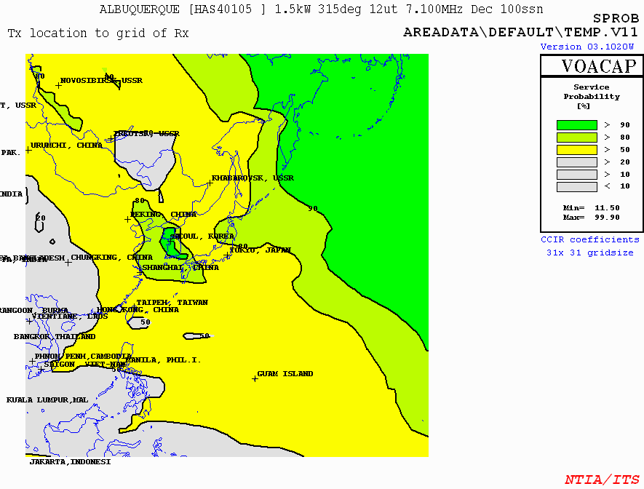

Figure 23, To Asia, 7.1 MHz (40 meters) with Antenna on 122 foot structure
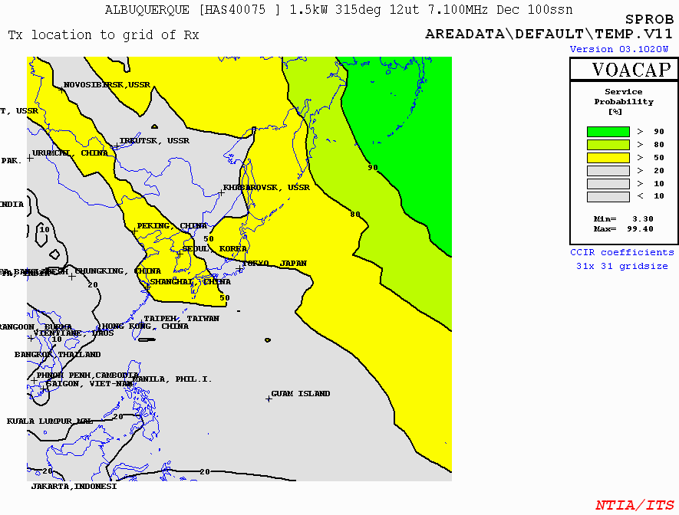

Figure 24, To Asia, 7.1 MHz (40 meters) with Antenna on 92 foot structure

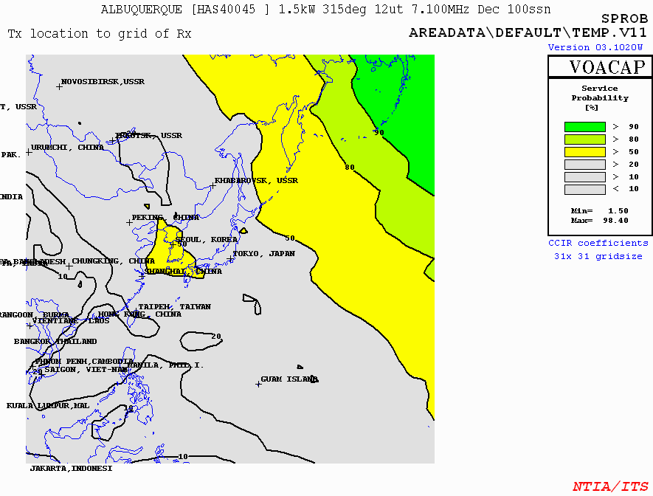

Figure 25, To Asia, 7.1 MHz (40 meters) with Antenna on 62 foot structure

20 Meters

Referring to Figures 26, 27 and 28 below, signals to Asia nearly meet the objective with the 92 foot structure (antenna is at 75 feet) (figure 27). A 122 foot structure (antenna at 115 feet) would completely meet the objective, however, Mr. Naumburg decided on the lower structure to be more compliant with the aesthetics of the neighborhood. The 62 foot structure (antenna at 55 feet) clearly does not meet the objective. These projections are in July at 0500 UTC. Twenty meters requires a light, daytime time path for long distance communications.

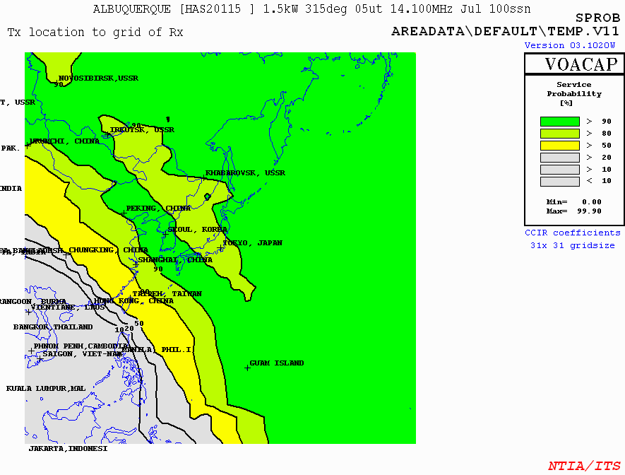

Figure 26, To Asia, 14.1 MHz (20 meters) with Antenna on 122 foot structure

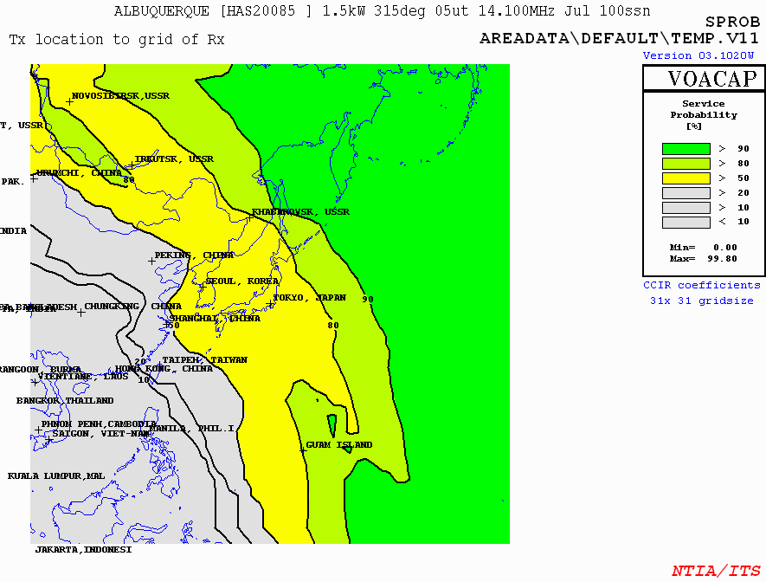

Figure 27, To Asia, 14.1 MHz (20 meters) with Antenna on 92 foot structure

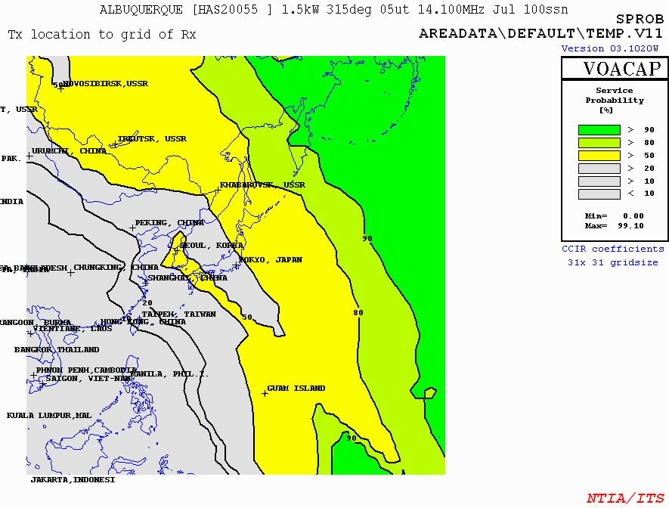

Figure 28, To Asia, 14.1 MHz (20 meters) with Antenna on 62 foot structure

Very High Frequency (VHF) Discussion

VHF communications are primarily line-of-sight, which means signals in this frequency range rarely bounce off the ionosphere. VHF is the primary set of frequencies used in local emergency communications. The communications need is to cover the greater Albuquerque area on a point-to-point, direct basis without the use of repeaters.

Mr. Naumburg uses a directional antenna to locate downed aircraft by homing in on their emergency locator transmitters (ELT). Aircraft cannot be located using repeaters.

During times of emergency events, such as fire, repeaters may fail. Mr. Naumburg is in a position to cover the area with his communications antennas.

Direct Coverage

Figure 29 shows the base map of the greater Albuquerque area with major roads included.

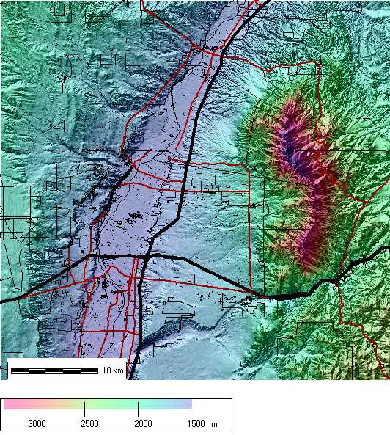

Figure 29, Base map of area.

Figure 30 shows the approximate area of VHF coverage (green) with the antenna on a 122 foot structure (antenna at 121 feet).

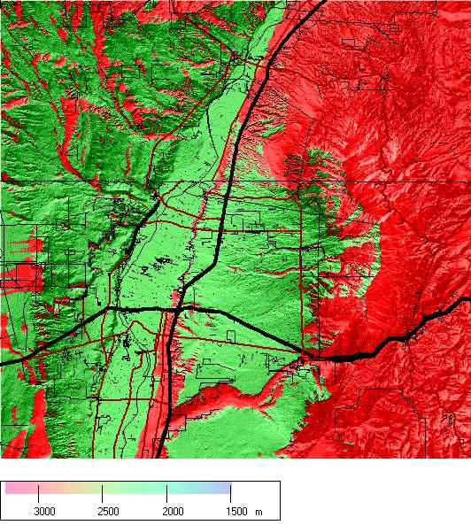

Figure 30, Coverage area (green) with Antenna on 122 foot structure
Figure 31 shows the approximate area of VHF coverage (green) with the antenna on a 92 foot structure (antenna at 91 feet).

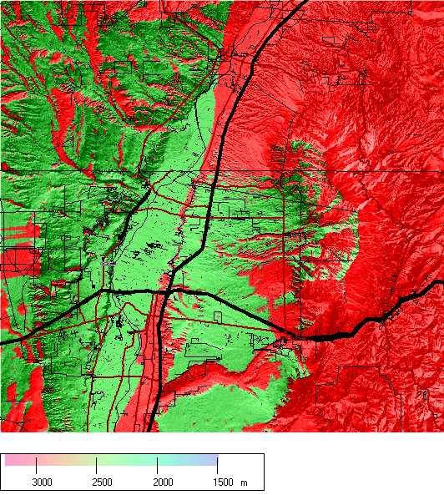

Figure 31, Coverage area (green) with Antenna on 92 foot structure
Figure 32 shows the approximate area of VHF coverage (green) with the antenna on a 62 foot structure (antenna at 61 feet).

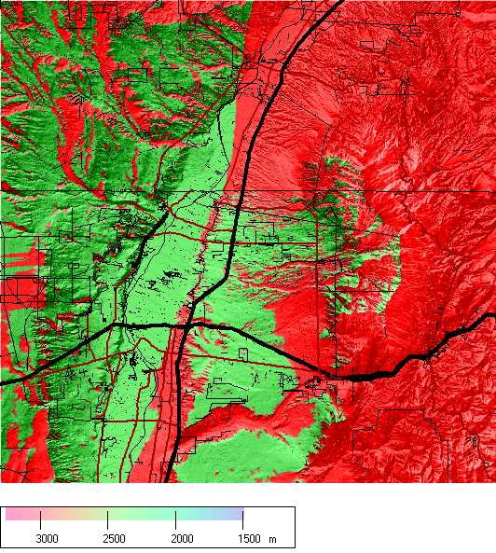

Figure 32, Coverage area (green) with Antenna on 62 foot structure

Performance with Current Antennas
on 92 foot Structure

The major conclusions about operations from the present structures are:

- While the 92 foot structure is, for some purposes a compromise in certain HF applications, Mr. Naumburg is willing to live with the sacrifice in performance.

- The 92 foot structure is adequate for Mr. Naumburg’s purposes, but provides far less than commercial quality communications, or even 75-90% communications effectiveness for long distance work.

- The 92 foot structure is necessary for VHF operations to support life saving emergency communications when, for whatever reason, in time of disaster a repeater may not be available or cannot be used.

With respect to HF, Mr. Naumburg put antennas on his current 92 foot structure on January 20, 2002. They work well. Through February 2004, he has made 1,040 contacts with amateurs around the world. He has made contacts with 202 radio countries. (A radio country is a sovereign country and/or a geographic entity. For these purposes, for example, Hawaii is a distinct radio country because it is separate from mainland USA). The radio country list Mr. Naumburg has made contact(s) with appears below.

Aland Island
Alaska
Albania
Algeria
American Samoa
Anguilla
Antarctica
Antigua; Barbuda
Argentina
Armenia
Aruba
Ascension Island
Asiatic Russia
Australia
Austria
Aves Island
Azores
Bahamas
Balearic Island
Barbados
Belarus
Belau
Belgium
Belize
Benin
Bermuda
Bhutan
Bolivia
Bosnia-Herzegovina
Brazil
British Virgin Islands
Bulgaria
Canada
Canary Island
Cape Verde
Cayman Islands
Central Kiribati
Ceuta & Melilla
Chagos
Chile
China
Cocos Island
Colombia
Costa Rica
Crete
Croatia
Cuba
Czech Republic
Denmark
Desecheo Island
Dominica
Dominican Rep
Ducie Island
East Kiribati
East Malaysia
East Timor (UNTAET)
Easter Island
Ecuador
El Salvador
England
Estonia
Ethiopia
European Russia
Falkland Islands
Faroe Islands
Fed. Rep. of Germany
Fernando de Noronha
Fiji
Finland
France
French Guiana
French Polynesia
Galapagos Island
Gambia
Georgia
Ghana
Gibraltar
Greece
Greenland
Grenada
Guadeloupe
Guantanamo Bay
Guatemala
Guernsey
Guinea
Guyana
Haiti
Hawaii
Honduras
Hong Kong
Hungary
Iceland
India
Indonesia
Ireland
Isle of Man
Israel
Italy
Ivory Coast
Jamaica
Japan
Johnston Island
Juan Fernandez
Kaliningradsk
Kazakhstan
Kenya
Kuwait
Kyrgyzstan
Latvia
Lebanon
Liberia
Liechtenstein
Lithuania
Lord Howe Island
Luxembourg
Madeira Island
Malawi
Mali
Mariana Island
Marshall Islands
Martinique
Mexico
Micronesia
Moldovia
Mongolia
Morocco
Myanmar (Burma)
Namibia
Netherland Antilles
Netherlands
New Caledonia
New Zealand
Nicaragua
Niger
Nigeria
Niue
Norfolk Island
North Korea
Northern Ireland
Norway
Oman
Pakistan
Palmyra; Jarvis Island
Panama
Papua New Guinea
Paraguay
Peru
Philippines
Poland
Portugal
Pratas Island
Puerto Rico
Revilla Gigedo
Rodriguez Island
Romania
San Andres & Providencia
San Marino
Sao Tome & Principe
Scotland
Senegal
Sierra Leone
Singapore
Slovak Republic
Slovenia
Solomon Island
South Africa
South Korea
Spain
St Helena
St Kitts & Nevis
St Lucia
St Maarten
St Martin
St Vincent
Surinam
Svalbard
Swaziland
Sweden
Switzerland
Thailand
Togo
Tokelau Island
Tonga
Trinidad & Tobago
Tristan da Cunha & Goug
Tunisia
Turks & Caicos Islands
Tuvalu
Ukraine
United Arab Emirates
United States
Uruguay
Vanuatu
Venezuela
Vietnam
Virgin Islands
Wales
West Malaysia
Western Sahara
Yugoslavia
Zambia
Zimbabwe

Search and Rescue Support
In New Mexico, search and rescue activities are conducted by teams. There are approximately 45 such teams, consisting of volunteers who are not compensated for their time or involvement. They are commissioned by the State of New Mexico Department of Public Safety, State Police Division. Mr. Naumburg is a member and former director of the New Mexico Search and Rescue Support Team (NMSARST).

NMSARST supports search and rescue and other critical emergency missions as requested by the New Mexico State Police. Located in Albuquerque, the team supports missions in the local area and across the state and country. The team provides communications, base camp support, electronic mapping, Automatic Position Reporting (APRS), ground search and rescue, 4WD & All Terrain Vehicle (ATV) search capabilities.

A common mission is searching for an Emergency Locator Transmitter (ELT). An ELT is a radio transmitter usually located in the rear of an airplane that transmits when an airplane makes a hard landing or is involved in a crash.

When an ELT signal in New Mexico is heard by Langley Air Force Base via satellites or by commercial airliners, which are required to monitor the frequency, the NMSARST team is deployed. The job is to locate and secure the ELT as soon as possible. This is critical for several reasons. If there has been an actual plane crash, the job is to find the plane and facilitate life saving activities within the “golden hour”, when chances of survival for accident victims are best. If there has not been an actual crash, the job is to find and secure the ELT as soon as possible so that the active ELT will not mask the ELT of an actual airplane accident.

Since the Russians have decommissioned several of their satellites used for monitoring ELTs, coverage is not as good as it was in the past. This makes it critical that the team respond as quickly as possible, because initial alerts are sometimes delayed. Many of the ELT missions are in the Albuquerque area because there are more air traffic operations in the Albuquerque area than any other place in the state.

Because the ELT transmits a non-directional signal, the satellite cannot determine if the active ELT is on the tarmac at the airport, in an arroyo at the end of the runway, or even at which airport. Using the vertically polarized, rotating log periodic antenna located on the top of Mr. Naumburg’s antenna support structure, the direction of the target signal can be identified.

Because the ELT signal is not discrete, it can be challenging to locate the source of the signal. Direction finding (DFing) techniques do this. DFing is as much an art form as a science. One of the biggest challenges when DFing an ELT, or other radio signals, is multi-path. Multi-path errors can be caused by refraction and reflection of the radio signal. A false reading is obtained because the signal actually arrives from a direction that is different from that of the source. At times, a direct signal from the source combines with a reflected signal from a mountain range creating another area of focus. In simple terms, you may swing the antenna to get the strongest signal possible, the problem being that the signal is actually being reflected from the Sandia Mountains and not the source.

After moving to his new home and not having access to an antenna system, there was an actual airplane crash in the mountains East of Albuquerque. The frustration of the SAR team’s inability to take advantage of an antenna system, coupled with a strong desire to reduce risk to lives endangered, prompted Mr. Naumburg to erect the current antenna system.

Because NMSARST is an all-volunteer team with limited resources for ELT missions, it is important to utilize available resources in the most efficient way possible. The ability to use the log periodic antenna to determine the location of the aircraft saves time and lives.

Many of the searches are in the Sandia Mountains. Being able to use the antenna system to DF the location of the search target is a life saving help. As with ELT missions, the height of the antenna is critical. Please see the VHF section of this document.
Being able to track our resources on a mission has been shown to cut time to the subject by as much as half. This is another function that is supported by the antenna system and has saved lives.
Mr. Naumburg’s system is also utilized to solve many other RF problems. Some recent examples of the antenna system at work are:

- An individual was intentionally interfering with (jamming) the prison radio system and with prison operation. The County was unable to locate the source of the transmission. Using Mr. Naumburg’s log periodic antenna, Mr. Naumburg was able to identify the offender. Every afternoon, the offender drove the same route, as he jammed the prison radio system. Because of the complexity of trying to locate a moving target without the use of the antenna system, the individual might not have ever been discovered.

- The antenna farm on top of the Sandia Mountains is a pool of RF (radio) energy. Sometimes these numerous sources interfere with each other, causing, for example, a loss of city communications and/or cell phone operation. The antenna system has been used to help solve these problems.

- Several sources of interference caused by bad connections and transformers in the PNM system were successfully located utilizing the antenna system.

- Mr. Naumburg is currently working with the FCC, utilizing his antenna system to monitor and locate a business which is interfering with a search and rescue frequency.

The team has responded on hundreds of missions throughout the State. In calendar year 2003, NMSARST has:

- responded to 22 missions in the Albuquerque area,
- responded to 12 missions outside the Albuquerque area,
- participated in the search for debris from the shuttle Columbia on two occasions and prepared extensive reports for the areas covered,
- responded to 14 Emergency Locator Transmitter (ELT) not associated with actual aircraft crashes. In most instances, the team located the transmitting ELT, or emission source, and assured that the ELT, or source, was shut down.
- responded to two aircraft crashes, assured the ELT was off and assisted in the investigation where possible,
- contributed more than 2,240 volunteer man-hours to state SAR activities,
- devoted more than 575 man-hours to training activities.

Since the erection of Mr. Naumburg’s antenna system, NMSARST has supported many missions. They are recapped in the appendix section of this document. Either by participation in the team directly or by use of Mr. Naumburg’s antenna system as a direction finding tool and communication utility, Mr. Naumburg has supported the missions, except when travel schedules were in conflict.

Character of the Area

A good example of the diversity of the Rural Agricultural Zone neighborhood where Mr. Naumburg resides is exemplified by the block where his antenna support structure is located.

Structures in the area:
- Bernalillo County Emergency Operations Center (EOC)
- Commercial cell phone tower (at the end of the block)
- 75 foot cell tower within a cross
- Commercial cell phone tower (by the Church)
- Albuquerque Fire station Number 5

The Bernalillo County Emergency Operations center is located at the end of Mr. Naumburg’s block. The EOC has employees manning the computers and telephones 24 hours a day. They have regular meetings with 30 or more people attending. Included in the EOC complex is an antenna support structure, larger in stature than Mr. Naumburg’s (figure 34).

Located directly across the street from the EOC is a commercial cell phone tower (figure 38).

One-half block south of Mr. Naumburg’s antenna support structure is a commercial cell tower disguised in a 75 foot cross (figure 37) and collocated on the same property is another commercial cell tower.

One and a half blocks east-southeast of Mr. Naumburg’s antenna support structure is Albuquerque Fire Station Number 5 (figure 36), which includes an antenna support structure.

After Bernalillo’s County’s refusal to receive Mr. Naumburg’s application for a building permit for his antenna support structure, a permit was granted by the County for an 80 foot wind generator (figure 39). The noise generated by a wind generator is arguably more imposing than Mr. Naumburg’s 80 foot antenna support structure.

People concerned about living with cows and horses, silos, windmills and wind generators, barns, steeples and antenna structures have an option. Many areas have common covenants and restraints (CC & Rs) that regulate and sterilize the area to address their concerns. North Albuquerque Acres, where Mr. Naumburg resides, is attractive to many because it does not have CC & Rs. The owners can use their land pretty much as they wish. If a homeowner wants to have a small tree farm, raise horses, goats or llamas, grow exotic plants or paint a home pink, s/he can do it in North Albuquerque Acres. It is the character of the area. This one Amateur Radio antenna support structure does not diverge from, or change, this character.

Amateur Radio antenna support structures have been incidental to and customary in residential areas since before we were born. In the past they have had no serious conflict with the character of the area.

Here are some photo examples:

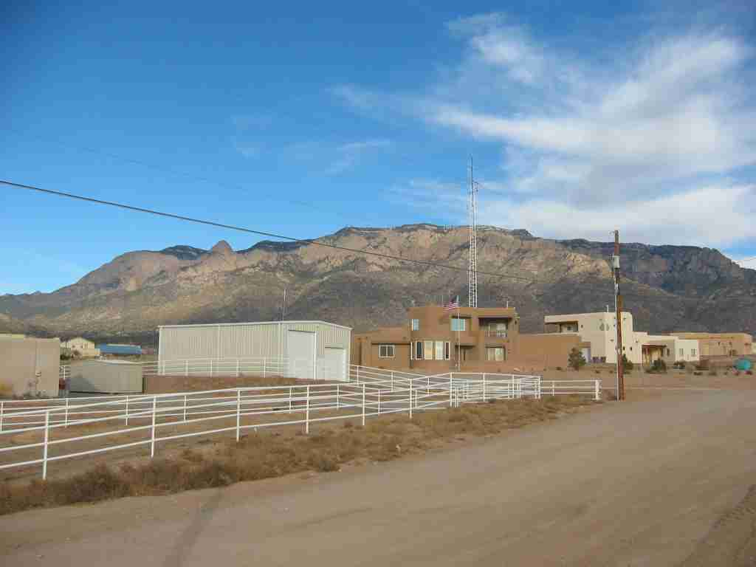

Figure 33, Mr. Naumburg’s residence showing antenna
Support structure. Taken from Holly looking East-Northeast

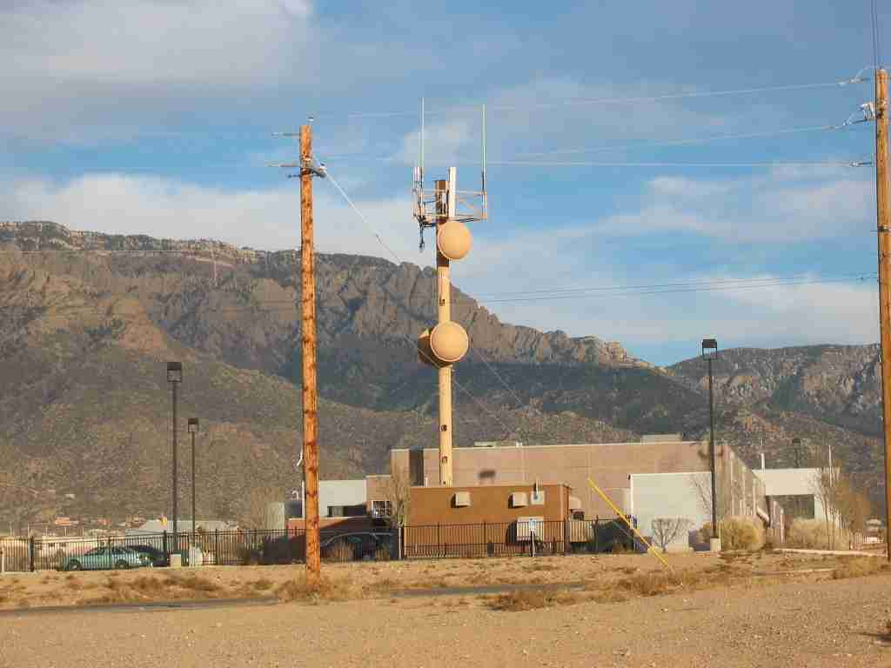

Figure 34, Bernalillo County Emergency Operations Center (EOC)
looking East-Northeast
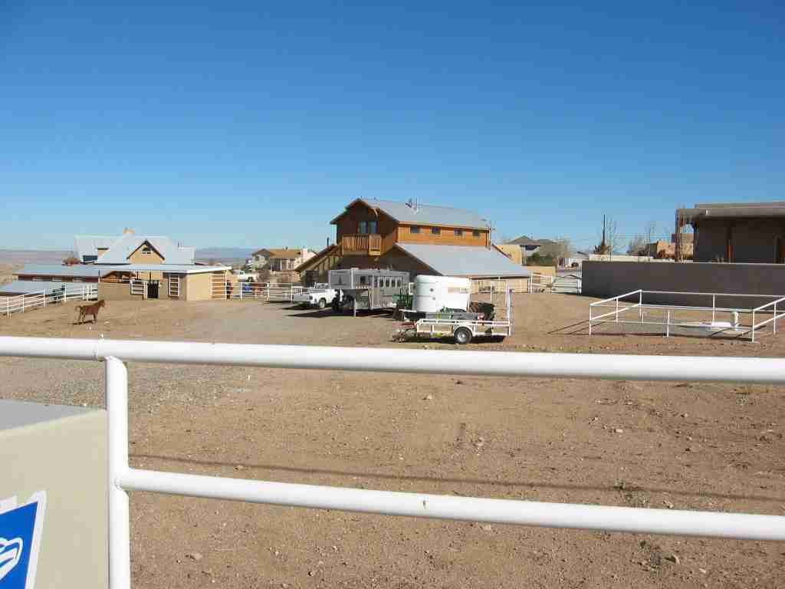

Figure 35, Mr. Naumburg’s immediate neighbor to the West
showing horse corrals and apparatus.

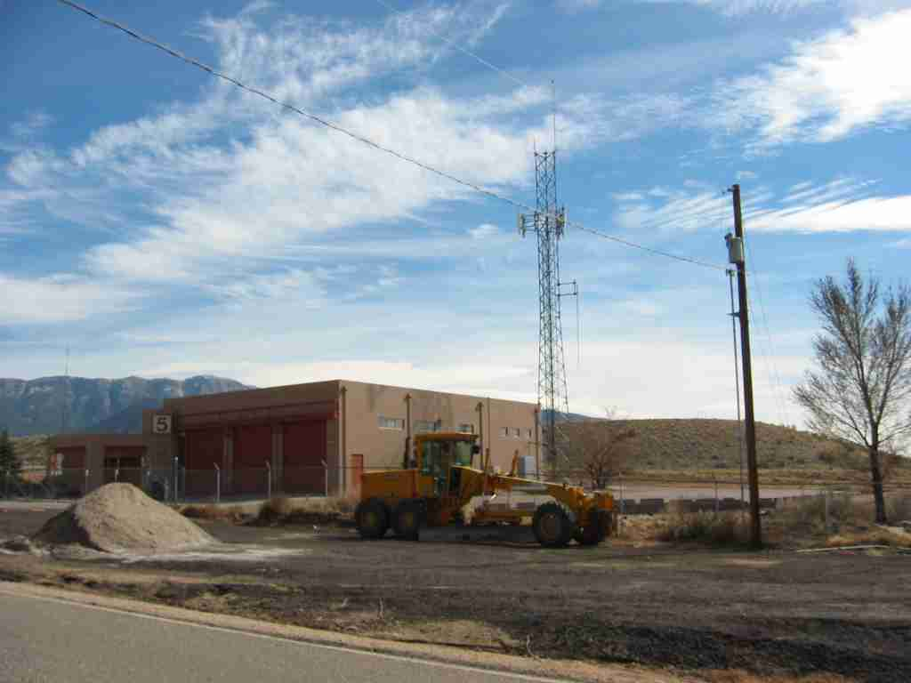

Figure 36, Bernalillo County fire station one and one-half blocks
East-Southeast of Mr. Naumburg’s residence.
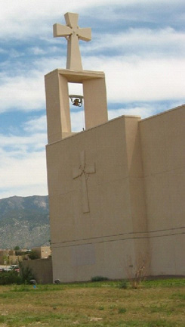

Figure 37, Church steeple which contain a cellular antenna. The
church is one-half block south of Mr. Naumburg’s residence.
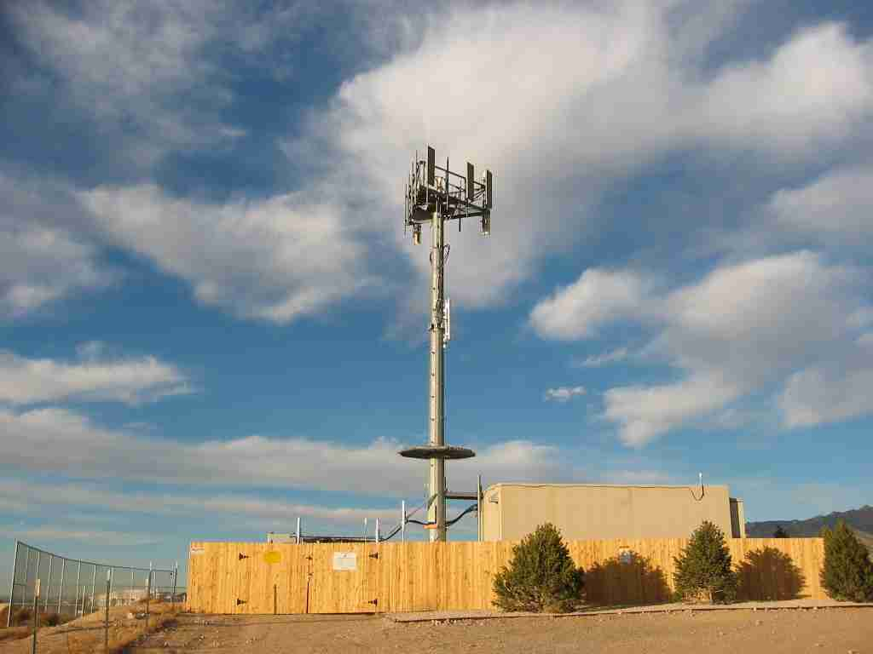

Figure 38, Cell tower located across the street from the
Bernalillo County EOC.

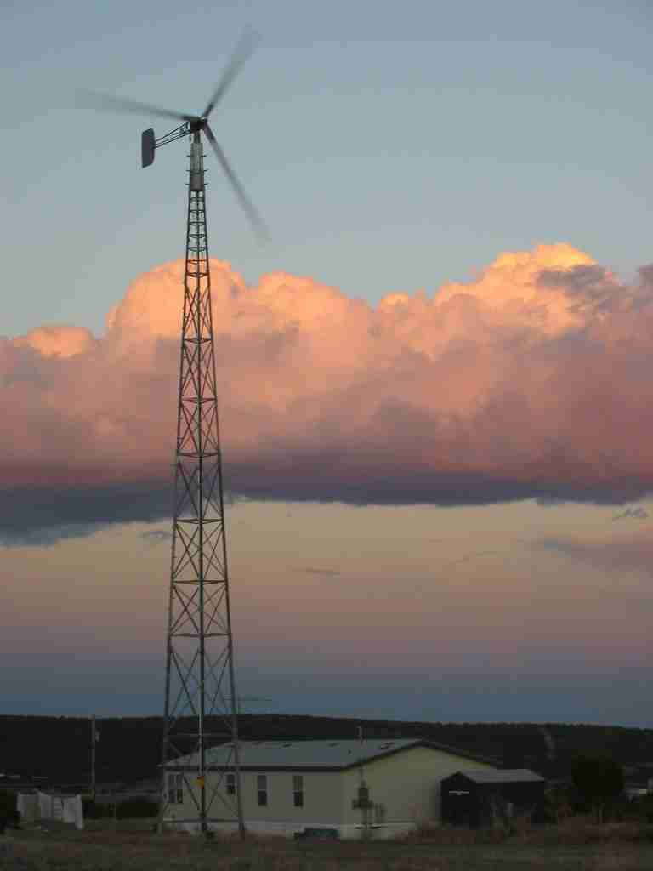

Figure 39, Wind generator, 80 feet not including
height of blades, approved as a permissive use by
Bernalillo County in an A-2 zone.

Effect on the Neighborhood of Mr. Naumburg’s Antenna Support Structure

Street System:

The amateur antenna support structure will not adversely effect traffic because if will not change the amount of traffic.

Sewer System:

The amateur antenna support structure will not adversely affect the sewer system because the area is not served by sewer. The amateur antenna support structure will not adversely affect septic systems.

Water System:

The amateur antenna support structure will not adversely affect water lines because the area is not served by a common water distribution system. The amateur antenna support structure will not adversely affect wells in the area.

Police Station:

The amateur antenna support structure will not adversely affect the police station because it will not increase crime or impact their activity. The antenna system supports the public safety mission of the Police.

Fire Station:

The amateur antenna support structure will not adversely affect the fire station because it will not create increase their activity. The antenna system supports the public safety mission of the Fire Department.

Parks:

The amateur antenna support structure will not adversely affect parks because there are no parks in the immediate area. If there were, the structure would have no impact.

Economic burden on citizens:

The amateur antenna support structure will not adversely affect the economic burden on the citizens of the area. Serving volunteer rescue purposes, it reduces the tax burden on citizens.

Garbage collection

The amateur antenna support structure will not adversely affect garbage collection because it will not increase the amount of garbage.

School system

The amateur antenna support structure will not adversely affect the school system, as no additional housing is involved.

Emergency Communication

The amateur antenna support structure will provide emergency communications, at no cost to the community, in times of need.

Appendix

Terrain Data

The first number in the columns is the distance, in meters, from the base of the tower. The second number is the elevation in meters.

Europe

0,1768.8
30,1767.81
60,1767.11
90,1768.14
120,1768.62
150,1769.87
180,1771.12
210,1771.99
240,1771.71
270,1771.14
300,1771.32
330,1771.63
360,1771.98
390,1771.62
420,1771.81
450,1772.00
480,1772.18
510,1772.50
540,1772.81
570,1772.86
600,1772.43
630,1772.74
660,1773.05
690,1773.37
720,1773.68
750,1773.99
780,1774.30
810,1774.91
840,1776.38
870,1777.66
900,1778.33
930,1778.86
960,1779.17
990,1779.48
1020,1779.79
1050,1780.10
1080,1780.42
1110,1780.77
1140,1781.29
1170,1783.08
1200,1784.32
1230,1786.79
1260,1788.08
1290,1789.40
1320,1789.16
1350,1789.22
1380,1789.53
1410,1789.84
1440,1790.66
1470,1791.91
1500,1792.86
1530,1793.12
1560,1793.85
1590,1793.94
1620,1794.02
1650,1794.33
1680,1794.65
1710,1794.96
1740,1795.27
1770,1796.77
1800,1797.00
1830,1797.20
1860,1796.86
1890,1796.83
1920,1797.14
1950,1796.98
1980,1797.18
2010,1798.43
2040,1799.57
2070,1800.09
2100,1800.84
2130,1800.61
2160,1800.66
2190,1801.88
2220,1802.95
2250,1803.00
2280,1805.33
2310,1807.69
2340,1809.88
2370,1811.56
2400,1812.69
2430,1813.94
2460,1814.75
2490,1815.45
2520,1816.37
2550,1816.86
2580,1817.79
2610,1817.31
2640,1817.62
2670,1817.93
2700,1818.47
2730,1819.51
2760,1821.54
2790,1823.77
2820,1825.56
2850,1827.39
2880,1828.71
2910,1829.96
2940,1831.08
2970,1832.05
3000,1832.36
3030,1832.57
3060,1832.97
3090,1833.29
3120,1833.60
3150,1833.81
3180,1832.92
3210,1834.09
3240,1830.35
3270,1828.64
3300,1832.58
3330,1837.03
3360,1840.69
3390,1844.47
3420,1848.56
3450,1851.68
3480,1853.78
3510,1854.73
3540,1855.96
3570,1861.53
3600,1866.50
3630,1870.85
3660,1879.35
3690,1892.68
3720,1904.80
3750,1918.83
3780,1935.25
3810,1953.43
3840,1968.25
3870,1979.21
3900,1985.91
3930,1987.36
3960,1986.30
3990,1988.17
4020,1995.51
4050,2005.21
4080,2006.11
4110,1998.85
4140,1988.54
4170,1980.82
4200,1973.61
4230,1949.22
4260,1925.24
4290,1913.72
4320,1905.28
4350,1897.81
4380,1894.50
4410,1894.53

Oceania

0,1768.8
30,1767.89
60,1766.99
90,1765.93
120,1764.78
150,1764.57
180,1764.32
210,1764.00
240,1762.47
270,1761.04
300,1759.70
330,1757.67
360,1755.32
390,1753.48
420,1753.14
450,1753.31
480,1753.41
510,1752.28
540,1751.01
570,1749.30
600,1747.82
630,1747.10
660,1744.97
690,1743.41
720,1741.68
750,1740.90
780,1741.13
810,1741.43
840,1740.64
870,1738.95
900,1737.64
930,1735.84
960,1734.51
990,1733.36
1020,1732.22
1050,1731.07
1080,1729.96
1110,1729.60
1140,1728.63
1170,1727.34
1200,1726.16
1230,1725.81
1260,1725.04
1290,1723.66
1320,1722.75
1350,1720.99
1380,1720.00
1410,1719.49
1440,1719.08
1470,1718.02
1500,1717.00
1530,1717.18
1560,1716.58
1590,1715.29
1620,1714.28
1650,1713.79
1680,1711.99
1710,1710.85
1740,1709.70
1770,1708.55
1800,1707.41
1830,1706.26
1860,1705.11
1890,1703.97
1920,1702.82
1950,1701.68
1980,1701.00
2010,1700.75
2040,1700.95
2070,1700.79
2100,1699.91
2130,1699.00
2160,1698.65
2190,1697.01
2220,1695.38
2250,1694.42
2280,1693.09
2310,1692.65
2340,1691.55
2370,1689.62
2400,1688.76
2430,1686.96
2460,1686.05
2490,1685.04
2520,1683.89
2550,1682.82
2580,1681.65
2610,1680.89
2640,1680.56
2670,1680.05
2700,1679.01
2730,1677.16
2760,1676.72
2790,1675.57
2820,1674.47
2850,1674.05
2880,1673.51
2910,1672.66
2940,1671.00
2970,1671.00
3000,1670.55
3030,1669.40
3060,1668.31
3090,1668.00
3120,1666.94
3150,1665.55
3180,1664.97
3210,1664.52
3240,1663.38
3270,1662.23
3300,1661.09
3330,1660.10
3360,1659.32
3390,1658.65
3420,1657.50
3450,1656.35
3480,1655.53
3510,1655.04
3540,1653.91
3570,1653.00
3600,1652.62
3630,1651.29
3660,1650.29
3690,1650.14
3720,1649.43
3750,1648.57
3780,1647.74
3810,1646.52
3840,1646.00
3870,1645.30
3900,1644.26
3930,1644.00
3960,1642.87
3990,1641.72
4020,1640.95
4050,1641.00
4080,1640.28
4110,1639.13
4140,1638.00
4170,1638.12
4200,1638.26
4230,1638.00
4260,1637.40
4290,1636.26
4320,1635.68
4350,1634.96
4380,1634.00
4410,1633.60

Asia

0,1768.8
30,1767.16
60,1765.41
90,1764.39
120,1763.04
150,1762.89
180,1762.75
210,1762.44
240,1761.49
270,1760.68
300,1759.95
330,1759.03
360,1759.13
390,1758.74
420,1757.42
450,1755.89
480,1754.75
510,1754.00
540,1753.17
570,1752.33
600,1751.73
630,1751.90
660,1752.45
690,1752.00
720,1751.16
750,1750.10
780,1749.29
810,1747.72
840,1747.62
870,1747.43
900,1746.39
930,1745.57
960,1745.00
990,1744.50
1020,1743.80
1050,1742.96
1080,1742.13
1110,1741.30
1140,1740.83
1170,1740.63
1200,1739.79
1230,1738.96
1260,1738.07
1290,1737.42
1320,1736.82
1350,1736.32
1380,1735.99
1410,1735.84
1440,1735.11
1470,1735.28
1500,1735.41
1530,1735.66
1560,1736.12
1590,1735.93
1620,1735.10
1650,1734.26
1680,1733.31
1710,1731.78
1740,1731.00
1770,1730.73
1800,1729.20
1830,1727.57
1860,1725.85
1890,1724.62
1920,1723.74
1950,1722.91
1980,1722.07
2010,1721.24
2040,1720.40
2070,1719.61
2100,1719.31
2130,1718.38
2160,1718.07
2190,1717.23
2220,1715.56
2250,1714.31
2280,1713.03
2310,1713.59
2340,1714.00
2370,1713.19
2400,1711.41
2430,1711.00
2460,1710.71
2490,1710.00
2520,1710.47
2550,1710.20
2580,1709.36
2610,1708.53
2640,1707.69
2670,1706.87
2700,1705.42
2730,1704.75
2760,1703.35
2790,1701.83
2820,1700.68
2850,1699.85
2880,1699.01
2910,1698.17
2940,1697.48
2970,1696.92
3000,1695.48
3030,1694.78
3060,1694.09
3090,1692.56
3120,1691.61
3150,1691.47
3180,1690.42
3210,1689.36
3240,1689.98
3270,1689.15
3300,1688.75
3330,1687.89
3360,1687.00
3390,1686.30
3420,1684.58
3450,1683.13
3480,1682.59
3510,1681.59
3540,1680.99
3570,1680.07
3600,1678.96
3630,1678.12
3660,1677.29
3690,1677.19
3720,1676.61
3750,1675.73
3780,1674.94
3810,1674.11
3840,1673.36
3870,1672.12
3900,1671.66
3930,1672.43
3960,1671.59
3990,1671.06
4020,1669.53
4050,1669.13
4080,1668.59
4110,1667.73
4140,1666.20
4170,1665.56
4200,1664.41
4230,1664.26
4260,1663.57
4290,1662.94
4320,1661.97
4350,1661.07
4380,1659.92
4410,1659.00

SAR Mission Listing

Recap of most missions the NMSARST team has been involved in since the erection of Mr. Naumburg’s antenna system.

DATE | Mission Number | Location | Summary
03/04/2004 | 04-10-01 | Bloomfield, NM | Search for a 47 year old male with diminished mental facilities who walked away from a nursing home. Team was to provide comm support with the trailer. Subject was found before team left Albuquerque.
03/03/2004 | 04-05-06 | Cabezon Area | Team provided communications and ATV support in connection with efforts to locate a public utility crew stranded due to inclement weather and bad road conditions in the San Luis/Cabezon area NW of San Ysidro.
02/22/2004 | 04-05-04 | Sandia Mountains | Search for an overdure hiker that left from the Canyon Estates trailhead. Subject was located on trail in good condition by a ground team from Cibola SAR. Team supplied base camp support and communications resources.
02/19/2004 | 04-20-04 | Kirtland AFB | ELT emissions detected in the vicinity of Kirtland AFB at approx. 2343 MST. The unit was quickly located and deactivated. ELT was part of a parachute unit found within a USAF C-130. Mission concluded at approx. 0125 MST.
02/17/2004 | NONE | N/A | Team was contacted for an ELT in the Albuquerque area. Members made initial data plots and preliminary measurements before it was determined that the ELT signal no longer existed by satellite measurements
02/16/2004 | 04-05-03 | Embudo Canyon | Rescue of a 47 year old male that had injured his ankle 2.0 miles up the Embudo trail. Team supplied communications, base camp support, 4 X 4, and ground support resources
02/10/2004 | 04-20-03 | Mid Valley Airport | Search for an ELT that was found at Mid Valley Airport and shut off by NMSARS personnel.
02/06/2004 | 04-05-02 | Embudo Canyon | Search for a 20 year-old mentally challenged male who strayed from a group outing at the East end of Candelaria. Individual found in good condition by a ground team in Embudo Canyon. Team provided Base camp support, communications and ground search resources
01/29/2004 | 04-20-02 | ABQ Sunport | Vehicle field teams Frank LoGrasso (team leader) and Rico Johnston located ELT in ABQ Sunport general aviation area and were coordinating with IC Tom Russo.
12/27/2003 | 03-09-03 | Near Anton Chico | Search for a lost 67 year-old male . Team supplied ATV, 4X4, communications, ground search and base camp support. This mission was the last and second longest mission for 2003 in terms of total team hours at 246.
12/20/2003 | 03-05-24 | Rio Puerco | 35-yr. old male stranded in the Rio Puerco Area while ATVing. Frank Lograsso provided ATV support by quickly locating the subject approximately 5 miles SW of basecamp (far western point of Southern Blvd.) and guiding him safely out of the area. Additional team members assisted with communications and APRS tracking support.
12/9/2003 | 03-05-23 | Valle Grande | Search for a lost 8 year old boy near the Valles Grande. Team provided ATV's base camp and communications support. Subject was located in excellent condition by ATV's provided by another team.
11/14/2003 | 03-20-22 | ABQ International Airport | Search for an ELT in the military section of Abq Int airport. ELT was turned off & on several times and then off for good during the final location stages and before team members could find the ELT.
11/13/2003 | 03-20-22 | Edgewood | ELT detected in vicinity of Edgewood, NM. Team quickly located the aircraft in a hanger at Sandia Airpark Estates East. The unit was deactivated by airport personnel.
11/09/2003 | 03-05-21 | Echo Canyon  Sandia Mountains | Rescue of a 35-year old lone male hiker in the Echo Canyon area of the Sandia Mountains. Team supplied basecamp and communications support.
11/04/2003 | 03-05-20 | Otero Canyon, Manzano Mtns. | Search for two female mountain bikers missing in the Otero  Canyon area. Team supplied basecamp, communications, ATV, and 4X4 support.
11/02/2003 | 03-01-21 | Rowe Mesa,  Pecos Wilderness | Search for a lost hunter on Rowe Mesa. Team requested to provided ATV support however the mission was canceled before team was formally activated.
10/23/2003 | 03-05-19 | La Luz Trail | Rescue of an injured female hiker, about 0.5 mi. below the "Y" on La Luz trail. Team supplied communications, basecamp, and ground team support
10/13/2003 | 03-10-03 | San Gregorio Lake | Search for a lost teenager and his father near the parking lot by San Gregorio Lake. Team supplied communications and basecamp support.
10/12/2003 | 03-10-02 | Nr. Cuba | Search for lost hunter near Cuba, NM. Team requested to provide communications, ground search, and ATV/4X4 resources. Mission ended sucessfully on 10/13/2003
10/12/2003 | 03-01-18 | Pecos Wilderness | Team asked to provide communications relay support and incident base communications for search involving lost hunter. Subject was found
10/04/2003 | 03-20-21 | Moriarty | Active ELT detected at Moriarty Airport. Team members responded and located the ELT in an aircraft undergoing maintenance
10/3/2003 | 03-10-01 | Nr. Cuba, NM | Team was requested to provide basecamp and ground team communications as well as 4WD capability in support of a search for a 19-year old female lost in the Torreon area SW of Cuba, NM. Subject was located in good health shortly after the arrival of team members.
10/02/2003 | 03-15-18 | La Luz Trail | Team provided incident base communications for rescue of a 52-year old woman who had injured her leg while traversing La Luz trail and had to be assisted off the mountain
9/30/2003 | 03-20-20 | Belen area | Team was asked to ensure that the ELT on a downed aircraft at Alexander airport in Belen was shut off.
9/25/2003 | 03-20-19 | ABQ Airport | Locate an ELT at the Albuquerque International Airport. Elt was found in the parachute building at Kirtland AFB.
9/18/2003 | 03-20-18 | ABQ Airport | Locate an ELT at the Albuquerque international Airport. ELT was found in a subterranean structure.
9/15/2003 | 03-05-17 | Sandia Crest | Rescue of a woman with a sprained ankle near the Kwanis cabin. Team supplied base camp support and comm. resources.
9/10/2003 | 03-05-16 | La Luz Trail | Rescue of a stranded woman on La Luz trail. Team supplied base camp support, comm. and ground support resources.
9/06/2003 | 03-05-15 | Sandia Mtns. | Rescue of a fallen climber and his climbing companion from the face of the shield. Team supplied base camp support and comm. resources.
9/02/2003 | 03-20-17 | Near Regina, NM | Search for an ELT near Regina. Personnel were turned around on their way to Regina when the ELT was turned off by state police. How all this came about was unknown. It appears that this was the same plane or same area where we turned off an ELT in 1996
8/29/2003 | 03-01-12 | Nr. Dixon Apple Farm | Search and rescue of two elderly women in or around the Dixon Apple Farm. Team asked to supply, ATV, 4WD and comm. resources. Personnel were turned around shortly after they got on the road, as subjects were located by local SAR resources.
8/28/2003 | 03-20-16 | Belen Area | Search for an ELT. It was located at the Alexander Airport, west of Belen, and shut off by airport personnel.
8/25/2003 | 03-06-07 | Near Grants, NM | Search for a lost 26 year old male near mile marker 60 on highway 53 southwest of Grants. Team provided, ATV, communication, mapping, APRS and base camp support. Subject was located by an incoming team which missed their turn off to base camp and found the subject!
8/17/2003 | 03-05-14 | Piedra Lisa Trail | 70 year-old male injured his knee while hiking. Requires litter evacuation. Team requested to provide Incident Base communications.
7/16/2003 | 03-20-13 | ABQ Airport | ELT mission.
7/14/2003 | 03-05-23 | Tramway  (Sandias) | Rescue of climbers who went up tramway path and became stranded near second tower. Team's communications resources were required to support high angle rescue teams. Subjects were evacuated without need for technical rescue.
7/13/2003 | 03-05-22 |  | All team resources were called out for a search for a missing 4-year old child, but child was found before team could respond.
7/04/2003 | 03-05-11 | La Luz Trail | Team was requested to provide incident base communications support for an injured hiker that had to be carried off the trail.
6/28/2003 | 03-05-10 | Embudito Trail | While still involved in the 6/28 Sandia Crest (03-15-09) search, our team provided additional communicators for the rescue of a male hiker who broke his ankle while on Embudito trail
6/24/2003 | 03-05-09 | Sandia Crest | Team provided communications and ground support for an extended search to locate a 74 year old female missing in the Sandia Crest area. Search began 6/24 about mid afternoon and initially ran until late evening. Search resumed 6/25, continued through the daylight hours and then was suspended until another effort was organized for Saturday 6/28. Hikers located subject's body late afternoon 6/28 about 1.5 miles above Las Huertas Canyon off Osha Springs Trail, team then relocated communication trailer to cover the recovery effort that was completed mid evening 6/28. Subject had been last seen about 6/21 but was not reported missing until 6/24.
6/19/2003 | 03-11-03 | Silver City | Team requested to provide satellite phone support and general communications assistance during a search north of Silver City for a missing female hiker. Shortly after the arrival of three team members, the subject was located in good health by searches already in place. Due to the remote location of the search area and extremely poor radio communication conditions, use of the satellite phone proved indispensable.
6/2/2003 | 03-05-08 | Doc Long Trail | 56 year old male became lost while on hike. Subject reported his predicament to law enforcement via cell phone. Team was requested to provide communications support and ground search. Subject walked out in good condition and was located by law enforcement officers before team was fully mobilized.
5/20/2003 | 03-05-07 | Nr. Belen | Missing 26 yr old man Team requested to respond with 4X4, ATV and ground teams. Mission ended 2 hours after initial callout.
5/10/2003 | 03-20-09 | Clines Corners | Report of ELT about 9 miles west of Clines Corners. Hits were on 243.0 MHz. There were several hits but ELT location team dispatched to the area failed to detect any signal from ground. Hits stopped and the mission was cancelled after several hours.
4/12/2003 | 03-05-05 | Pino Canyon Trail | Woman hiker with reported broken ankle reported on the trail. When search teams reached subject, they believed she instead suffered a bad sprain. Subject was evacuated by litter team. Evacuation was somewhat delayed because of need to replace wheel on the litter. NMSAR Team resources included communications and base camp support for this mission.
4/5/2003 | 03-05-04 | Otero Canyon | Report of two lost mountain bikers in Otero Canyon. Team was requested to provide ATV search, 4WD search, communications support, and incident base support. Subjects walked out in good condition shortly after team was called.
3/27/2003 | 03-20-05 | Mid Valley Airport near Los Lunas | Team was asked to locate a 243mHz ELT which had 4 satellite hits near or east of Belen. An additional satellite hit was also recorded on 121.50 MHz just after team call out. Field team located the ELT in an aircraft within a repair and inspection hanger located at Mid-Valley Airport near Los Lunas. Since the hanger was located within the residential airport setting of Mid-Valley, the team accompanied by State Police in the final search phase where hangers were intermixed with home sites.
3/15/2003 | 03-30-02 | Manzano Mountains | We have been asked again to support a space shuttle debris search. The search is based on better radar tracking data and is a smaller area, approximately 84 acres in the East Mountains.  Communications support was provided for approximately 50 trained volunteer searchers. No shuttle debris was found
3/14/2003 | 03-20-04 | Double Eagle Airport | Team was called out to locate ELT at or near Double Eagle airport. Mission was terminated about 20 minutes later.
3/7/2003 | 03-20-03 | Near Double Eagle Airport | The team was requested to provide ELT, 4 X4 and  ATV resources for a downed aircraft in the vicinity of Double Eagle airport. There was credible evidence that the plane had gone down based on an open flight plan and an eye witness account. The team was instructed by the Area Commander to stand down except for one individual to check if an ELT had been activated. Rob Ambrose responded, and in addition to turning off the ELT, took photographs for OMI and NTSB.  The plane had crashed about 2 miles northeast of Double Eagle after striking power lines. There were no survivors.
3/4/2003 | 03-05-03 | Upper La Luz Trail | One of three hikers on the upper part of the La Luz trail reported to be suffering from a medical condition. Team was requested to provide incident base communications and support, as well as additional communications at top of mountain where ground resources will be inserted. Subject was recovered and transported to hospital.
2/15/2003 | 03-30-01 | Embudito Canyon,  Sandia Mtns. | Based on a number of sources and analysis, NASA had reason to believe that debris from the shuttle Columbia may have impacted in Embudito Canyon. The NM SAR Support Team was requested to provide communications and incident base support for a massive search involving more than 150 searchers from around the state. Although several small objects were found in the rugged terrain, none were attributed to the Columbia.
2/4/2003 | 03-06-01 | Bluewater Lake area | 28 year old male missing from a camp site near Post Office flat resulted in a search mission. Team resources, including communications support, ATV and ground team search were requested. Subject was located in good condition by searchers.
1/27/2003 | 03-12-01 | Pinos Altos | 81-Year-old Alzheimer patient missing over 24 hours in the Pinos Altos area north of Silver City, NM. Team requested to provide relief ground and vehicular search assistance. Subject found in good condition by searchers already in the field shortly after the arrival of team members.
1/18/2003 | 03-05-02 | Tramway | Report of hikers stranded at the second tram tower. Team was requested to provide communications and incident base support. Hikers were escorted down to the tram parking lot early morning, 1/19/2003

http://gisdata.usgs.net/NED/default.asp
American Radio Relay League, R. Dean Straw, author, http://arrl.org
http://elbert.its.bldrdoc.gov/hf.html

